PRACTICAL1
Android Basics and Resources
- Develop a simple “Hello World” Android application demonstrating project creation, Android Studio interface, Android components, AVD creation, and application execution.

MainActivity.kt
package com.example.practical1
import android.os.Bundle
import androidx.activity.enableEdgeToEdge
import androidx.appcompat.app.AppCompatActivity
import androidx.core.view.ViewCompat
import androidx.core.view.WindowInsetsCompat
class MainActivity : AppCompatActivity() {
override fun onCreate(savedInstanceState: Bundle?) {
super.onCreate(savedInstanceState)
enableEdgeToEdge()
setContentView(R.layout.activity_main)
ViewCompat.setOnApplyWindowInsetsListener(findViewById(R.id.main)) { v, insets ->
val systemBars = insets.getInsets(WindowInsetsCompat.Type.systemBars())
v.setPadding(systemBars.left, systemBars.top, systemBars.right, systemBars.bottom)
insets
}
}
}

Activity_main.xml
<?xml version="1.0" encoding="utf-8"?>
<androidx.constraintlayout.widget.ConstraintLayout xmlns:android="http://schemas.android.com/apk/res/android"
xmlns:app="http://schemas.android.com/apk/res-auto"
xmlns:tools="http://schemas.android.com/tools"
android:id="@+id/main"
android:layout_width="match_parent"
android:layout_height="match_parent"
tools:context=".MainActivity">
<TextView
android:layout_width="wrap_content"
android:layout_height="wrap_content"
android:text="Hello World!"
app:layout_constraintBottom_toBottomOf="parent"
app:layout_constraintEnd_toEndOf="parent"
app:layout_constraintStart_toStartOf="parent"
app:layout_constraintTop_toTopOf="parent" />
</androidx.constraintlayout.widget.ConstraintLayout>
Output:-
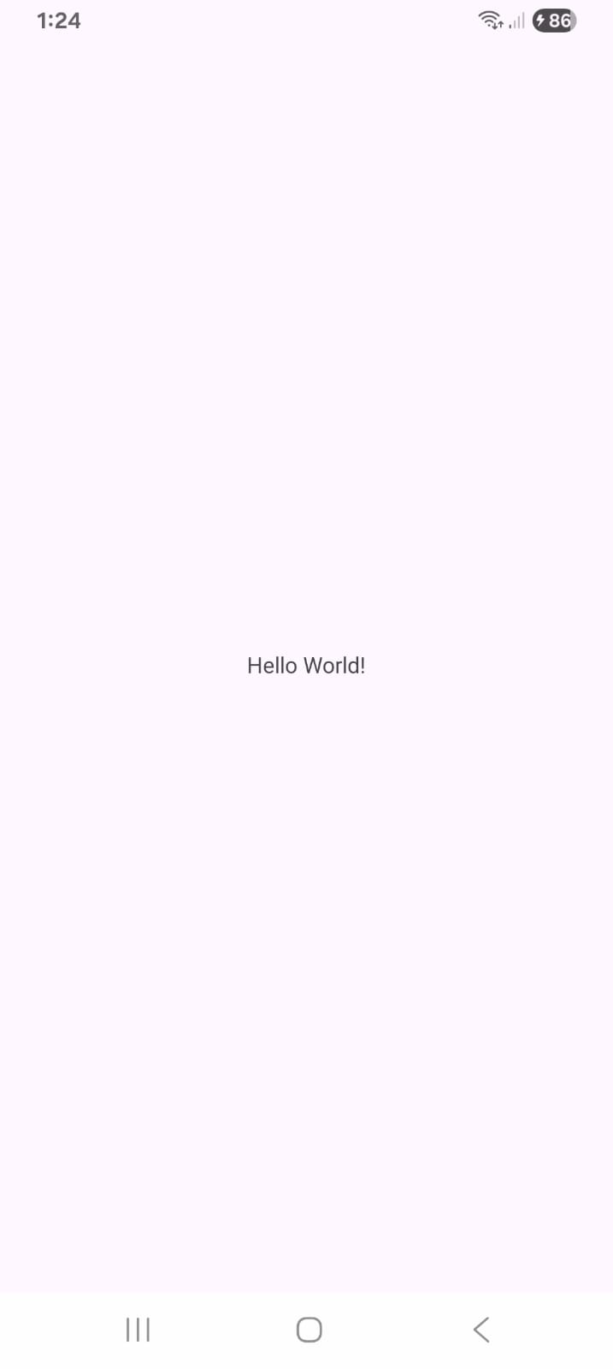
- Develop an Android application demonstrating the use of Programming Resources (colors.xml, themes.xml, strings.xml, dimens.xml, drawable resources) and apply them in UI components.
colors.xml
<?xml version="1.0" encoding="utf-8"?>
<resources>
<color name="primary_color">#3F51B5</color>
<color name="secondary_color">#FF4081</color>
<color name="background_color">#F5F5F5</color>
<color name="text_color">#000000</color>
<color name="white">#FFFFFF</color>
</resources>

strings.xml
<resources>
<string name="app_name">practical 2</string>
<string name="title">Student Information</string>
<string name="name_hint">Enter your name</string>
<string name="course_hint">Enter your course</string>
<string name="submit">Submit</string>
<string name="welcome_message">Welcome to Android Programming</string>
</resources>

dimens.xml
<?xml version="1.0" encoding="utf-8"?>
<resources>
<dimen name="screen_padding">20dp</dimen>
<dimen name="title_size">26sp</dimen>
<dimen name="text_size">18sp</dimen>
<dimen name="input_height">55dp</dimen>
<dimen name="button_height">55dp</dimen>
<dimen name="margin_top">15dp</dimen>
</resources>

Drawable:
Create a drawable resource for the button.
Go to: app → res → drawable
Right-click: New → Drawable Resource File
Name it: rounded_button.xml
rounded_button.xml
<?xml version="1.0" encoding="utf-8"?>
<shape xmlns:android="http://schemas.android.com/apk/res/android"
android:shape="rectangle">
<solid android:color="@color/primary_color" />
<corners android:radius="12dp" />
<padding
android:left="10dp"
android:top="10dp"
android:right="10dp"
android:bottom="10dp" />
</shape>
For Wallpaper Image
1. Right click on drawable folder
2. Copy the image if you want to create image drawable
3. Paste that image file inside the drawable folder

Themes.xml
<?xml version="1.0" encoding="utf-8"?>
<resources xmlns:tools="http://schemas.android.com/tools">
<style
name="Theme.Practical2"
parent="Theme.Material3.DayNight.NoActionBar">
<item name="android:fontFamily">sans</item>
<item name="android:colorAccent">@color/secondary_color</item>
<item name="android:windowBackground">@color/background_color</item>
</style>
</resources>

MainActivity.kt
package com.example.practical2
import android.os.Bundle
import android.widget.Button
import android.widget.EditText
import android.widget.TextView
import androidx.appcompat.app.AppCompatActivity
class MainActivity : AppCompatActivity() {
override fun onCreate(savedInstanceState: Bundle?) {
super.onCreate(savedInstanceState)
setContentView(R.layout.activity_main)
val etName = findViewById<EditText>(R.id.etName)
val etCourse = findViewById<EditText>(R.id.etCourse)
val btnSubmit = findViewById<Button>(R.id.btnSubmit)
val tvMessage = findViewById<TextView>(R.id.tvMessage)
btnSubmit.setOnClickListener {
val name = etName.text.toString()
val course = etCourse.text.toString()
tvMessage.text = "Hello $name!\nCourse: $course"
}
}
}

Activity_main.xml
<?xml version="1.0" encoding="utf-8"?>
<LinearLayout xmlns:android="http://schemas.android.com/apk/res/android"
android:layout_width="match_parent"
android:layout_height="match_parent"
android:orientation="vertical"
android:gravity="center_horizontal"
android:padding="@dimen/screen_padding"
android:background="@drawable/wallpaper">
<TextView
android:id="@+id/tvTitle"
android:layout_width="match_parent"
android:layout_height="wrap_content"
android:text="@string/title"
android:textSize="@dimen/title_size"
android:textStyle="bold"
android:textColor="@color/primary_color"
android:gravity="center"
android:padding="@dimen/screen_padding" />
<EditText
android:id="@+id/etName"
android:layout_width="match_parent"
android:layout_height="@dimen/input_height"
android:layout_marginTop="@dimen/margin_top"
android:hint="@string/name_hint"
android:textColorHint="@color/text_color"
android:textSize="@dimen/text_size"
android:inputType="text" />
<EditText
android:id="@+id/etCourse"
android:layout_width="match_parent"
android:layout_height="@dimen/input_height"
android:layout_marginTop="@dimen/margin_top"
android:hint="@string/course_hint"
android:textColorHint="@color/text_color"
android:textSize="@dimen/text_size"
android:inputType="text" />
<Button
android:id="@+id/btnSubmit"
android:layout_width="match_parent"
android:layout_height="@dimen/button_height"
android:layout_marginTop="@dimen/margin_top"
android:text="@string/submit"
android:textColor="@color/white"
android:background="@drawable/rounded_button" />
<TextView
android:id="@+id/tvMessage"
android:layout_width="match_parent"
android:layout_height="wrap_content"
android:layout_marginTop="@dimen/margin_top"
android:text="@string/welcome_message"
android:textSize="@dimen/text_size"
android:textColor="@color/text_color"
android:gravity="center" />
</LinearLayout>

Output:-

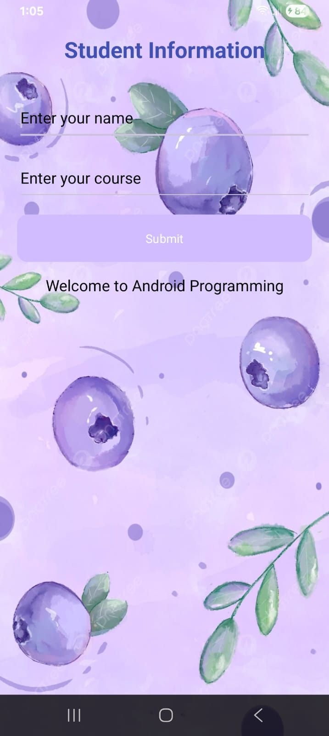
3. Develop an Android application demonstrating complete Activity Lifecycle methods and analyze execution using Logcat.

MainActivity.kt
package com.example.practical3
import android.os.Bundle
import android.util.Log
import androidx.appcompat.app.AppCompatActivity
class MainActivity : AppCompatActivity() {
private val TAG = "ActivityLifecycle"
override fun onCreate(savedInstanceState: Bundle?) {
super.onCreate(savedInstanceState)
setContentView(R.layout.activity_main)
Log.d(TAG, "onCreate() called")
}
override fun onStart() {
super.onStart()
Log.d(TAG, "onStart() called")
}
override fun onResume() {
super.onResume()
Log.d(TAG, "onResume() called")
}
override fun onPause() {
super.onPause()
Log.d(TAG, "onPause() called")
}
override fun onStop() {
super.onStop()
Log.d(TAG, "onStop() called")
}
override fun onRestart() {
super.onRestart()
Log.d(TAG, "onRestart() called")
}
override fun onDestroy() {
super.onDestroy()
Log.d(TAG, "onDestroy() called")
}
}

Activity_main.xml
<?xml version="1.0" encoding="utf-8"?>
<LinearLayout xmlns:android="http://schemas.android.com/apk/res/android"
android:layout_width="match_parent"
android:layout_height="match_parent"
android:orientation="vertical"
android:gravity="center"
android:padding="20dp">
<TextView
android:layout_width="wrap_content"
android:layout_height="wrap_content"
android:text="Activity Lifecycle Demo"
android:textSize="24sp"
android:textStyle="bold" />
<TextView
android:layout_width="wrap_content"
android:layout_height="wrap_content"
android:layout_marginTop="20dp"
android:text="Check Logcat to observe lifecycle methods"
android:textSize="16sp" />
</LinearLayout>

Output:-

PRACTICAL 2

Fragments and Activity Interaction
1. Develop an Android application to create and integrate a Fragment and demonstrate Fragment lifecycle methods.
Activity_main.xml
<?xml version="1.0" encoding="utf-8"?>
<LinearLayout xmlns:android="http://schemas.android.com/apk/res/android"
android:layout_width="match_parent"
android:layout_height="match_parent"
android:orientation="vertical"
android:padding="16dp">
<TextView
android:layout_width="match_parent"
android:layout_height="wrap_content"
android:text="Task 4: Fragment Lifecycle Demo"
android:textSize="20sp"
android:textStyle="bold"
android:gravity="center"
android:layout_marginBottom="16dp" />
<Button
android:id="@+id/btnLoadFragment"
android:layout_width="match_parent"
android:layout_height="wrap_content"
android:text="Load Lifecycle Fragment" />
<androidx.fragment.app.FragmentContainerView
android:id="@+id/fragmentContainer"
android:layout_width="match_parent"
android:layout_height="0dp"
android:layout_weight="1"
android:layout_marginTop="16dp"
android:background="#ECEFF1" />
</LinearLayout>
Fragment_home.xml
<?xml version="1.0" encoding="utf-8"?>
<LinearLayout xmlns:android="http://schemas.android.com/apk/res/android"
android:layout_width="match_parent"
android:layout_height="match_parent"
android:orientation="vertical"
android:gravity="center">
<TextView
android:id="@+id/tvFragment"
android:layout_width="wrap_content"
android:layout_height="wrap_content"
android:text="Hello from Fragment!"
android:textSize="24sp"
android:textStyle="bold" />
</LinearLayout>
LifeCycleFragment.kt
package com.example.fragmentmasterapp
import android.content.Context
import android.os.Bundle
import android.util.Log
import android.view.LayoutInflater
import android.view.View
import android.view.ViewGroup
import androidx.fragment.app.Fragment
class LifecycleFragment : Fragment() {
companion object {
private const val TAG = "FragmentLifecycleTest"
}
override fun onAttach(context: Context) {
super.onAttach(context)
Log.d(TAG, "onAttach: Fragment attached to Activity")
}
override fun onCreate(savedInstanceState: Bundle?) {
super.onCreate(savedInstanceState)
Log.d(TAG, "onCreate: Fragment initialized")
}
override fun onCreateView(
inflater: LayoutInflater, container: ViewGroup?,
savedInstanceState: Bundle?
): View? {
Log.d(TAG, "onCreateView: Inflating fragment layout")
return inflater.inflate(R.layout.fragment_lifecycle, container, false)
}
override fun onViewCreated(view: View, savedInstanceState: Bundle?) {
super.onViewCreated(view, savedInstanceState)
Log.d(TAG, "onViewCreated: Views bound successfully")
}
override fun onStart() {
super.onStart()
Log.d(TAG, "onStart: Fragment visible")
}
override fun onResume() {
super.onResume()
Log.d(TAG, "onResume: Fragment interactive")
}
override fun onPause() {
super.onPause()
Log.d(TAG, "onPause: Fragment losing focus")
}
override fun onStop() {
super.onStop()
Log.d(TAG, "onStop: Fragment stopped")
}
override fun onDestroyView() {
super.onDestroyView()
Log.d(TAG, "onDestroyView: Fragment view destroyed")
}
override fun onDestroy() {
super.onDestroy()
Log.d(TAG, "onDestroy: Fragment instance destroyed")
}
override fun onDetach() {
super.onDetach()
Log.d(TAG, "onDetach: Fragment detached from Activity")
}
}
MainActivity.kt
package com.example.fragmentmasterapp
import android.os.Bundle
import android.widget.Button
import androidx.appcompat.app.AppCompatActivity
class MainActivity : AppCompatActivity() {
override fun onCreate(savedInstanceState: Bundle?) {
super.onCreate(savedInstanceState)
setContentView(R.layout.activity_main)
val btnLoad = findViewById<Button>(R.id.btnLoadFragment)
btnLoad.setOnClickListener {
supportFragmentManager.beginTransaction()
.replace(R.id.fragmentContainer, LifecycleFragment())
.commit()
}
}
}

Output:-
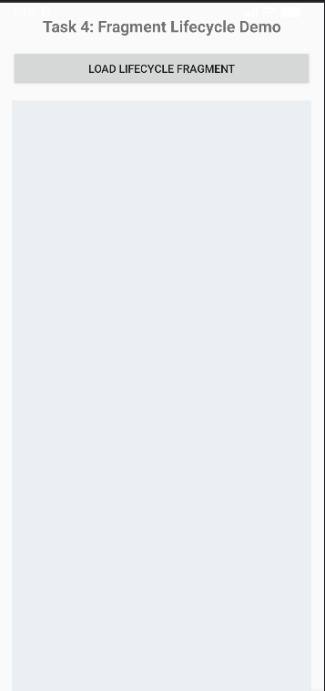
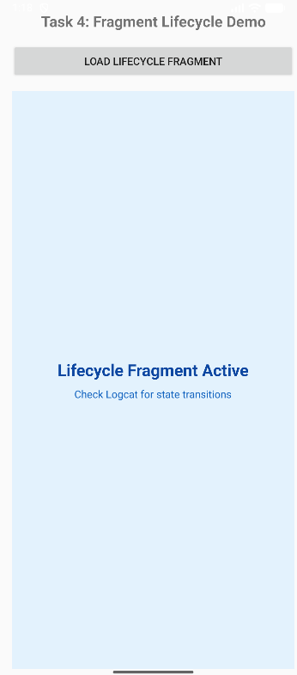
2. Develop an Android application implementing Fragment-based UI navigation between multiple screens.
activity_main.xml
<?xml version="1.0" encoding="utf-8"?>
<LinearLayout xmlns:android="http://schemas.android.com/apk/res/android"
android:layout_width="match_parent"
android:layout_height="match_parent"
android:orientation="vertical">

<TextView
android:layout_width="match_parent"
android:layout_height="wrap_content"
android:text="Fragment Navigation"
android:textSize="24sp"
android:textStyle="bold"
android:gravity="center"
android:padding="16dp" />

<androidx.fragment.app.FragmentContainerView
android:id="@+id/fragmentContainer"
android:layout_width="match_parent"
android:layout_height="0dp"
android:layout_weight="1" />

<LinearLayout
android:layout_width="match_parent"
android:layout_height="wrap_content"
android:orientation="horizontal">

<Button
android:id="@+id/btnHome"
android:layout_width="0dp"
android:layout_height="wrap_content"
android:layout_weight="1"
android:text="Home" />

<Button
android:id="@+id/btnProfile"
android:layout_width="0dp"
android:layout_height="wrap_content"
android:layout_weight="1"
android:text="Profile" />

<Button
android:id="@+id/btnSettings"
android:layout_width="0dp"
android:layout_height="wrap_content"
android:layout_weight="1"
android:text="Settings" />
</LinearLayout>
</LinearLayout>
fragment_home.xml
<?xml version="1.0" encoding="utf-8"?>
<LinearLayout xmlns:android="http://schemas.android.com/apk/res/android"
android:layout_width="match_parent"
android:layout_height="match_parent"
android:orientation="vertical"
android:gravity="center"
android:background="#E8F5E9">

<TextView
android:layout_width="wrap_content"
android:layout_height="wrap_content"
android:text="Home Screen"
android:textSize="28sp"
android:textStyle="bold"
android:textColor="#2E7D32" />
</LinearLayout>
fragment_profile.xml
<?xml version="1.0" encoding="utf-8"?>
<LinearLayout xmlns:android="http://schemas.android.com/apk/res/android"
android:layout_width="match_parent"
android:layout_height="match_parent"
android:orientation="vertical"
android:gravity="center"
android:background="#E8F5E9">

<TextView
android:layout_width="wrap_content"
android:layout_height="wrap_content"
android:text="Home Screen"
android:textSize="28sp"
android:textStyle="bold"
android:textColor="#2E7D32" />
</LinearLayout>
fragment_settings.xml
<?xml version="1.0" encoding="utf-8"?>
<LinearLayout xmlns:android="http://schemas.android.com/apk/res/android"
android:layout_width="match_parent"
android:layout_height="match_parent"
android:orientation="vertical"
android:gravity="center"
android:background="#FFF3E0">

<TextView
android:layout_width="wrap_content"
android:layout_height="wrap_content"
android:text="Settings Screen"
android:textSize="28sp"
android:textStyle="bold"
android:textColor="#EF6C00" />
</LinearLayout>
MainActivity.kt
package com.example.fragmentmasterapp

import android.os.Bundle
import android.widget.Button
import androidx.appcompat.app.AppCompatActivity

class MainActivity : AppCompatActivity() {
override fun onCreate(savedInstanceState: Bundle?) {
super.onCreate(savedInstanceState)
setContentView(R.layout.activity_main)

val btnHome = findViewById<Button>(R.id.btnHome)
val btnProfile = findViewById<Button>(R.id.btnProfile)
val btnSettings = findViewById<Button>(R.id.btnSettings)

// Load HomeFragment by default on app launch
if (savedInstanceState == null) {
supportFragmentManager.beginTransaction()
.replace(R.id.fragmentContainer, HomeFragment())
.commit()
}

btnHome.setOnClickListener {
supportFragmentManager.beginTransaction()
.replace(R.id.fragmentContainer, HomeFragment())
.commit()
}

btnProfile.setOnClickListener {
supportFragmentManager.beginTransaction()
.replace(R.id.fragmentContainer, ProfileFragment())
.commit()
}

btnSettings.setOnClickListener {
supportFragmentManager.beginTransaction()
.replace(R.id.fragmentContainer, SettingsFragment())
.commit()
}
}
}
HomeFragment.kt
package com.example.fragmentmasterapp

import android.os.Bundle
import android.view.LayoutInflater
import android.view.View
import android.view.ViewGroup
import androidx.fragment.app.Fragment

class HomeFragment : Fragment() {
override fun onCreateView(
inflater: LayoutInflater,
container: ViewGroup?,
savedInstanceState: Bundle?
): View {
return inflater.inflate(R.layout.fragment_home, container, false)
}
}
ProfileFragment.kt
package com.example.fragmentmasterapp

import android.os.Bundle
import android.view.LayoutInflater
import android.view.View
import android.view.ViewGroup
import androidx.fragment.app.Fragment

class ProfileFragment : Fragment() {
override fun onCreateView(
inflater: LayoutInflater,
container: ViewGroup?,
savedInstanceState: Bundle?
): View {
return inflater.inflate(R.layout.fragment_profile, container, false)
}
}
SettingsFragment.kt
package com.example.fragmentmasterapp

import android.os.Bundle
import android.view.LayoutInflater
import android.view.View
import android.view.ViewGroup
import androidx.fragment.app.Fragment

class SettingsFragment : Fragment() {
override fun onCreateView(
inflater: LayoutInflater,
container: ViewGroup?,
savedInstanceState: Bundle?
): View {
return inflater.inflate(R.layout.fragment_settings, container, false)
}
}
Output:-
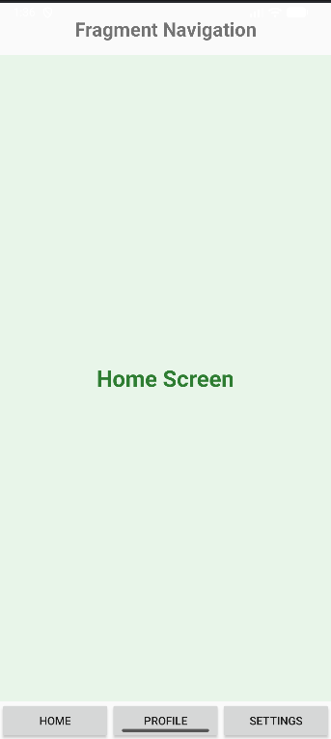
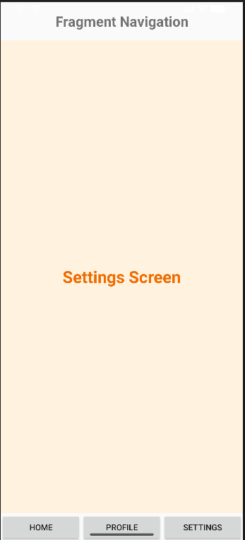
3. Develop an Android application demonstrating communication between Activity and Fragment.

Activitymain.xml
<?xml version="1.0" encoding="utf-8"?>
<LinearLayout xmlns:android="http://schemas.android.com/apk/res/android"
android:layout_width="match_parent"
android:layout_height="match_parent"
android:orientation="vertical"
android:padding="20dp">

<TextView
android:layout_width="match_parent"
android:layout_height="wrap_content"
android:text="Activity - Fragment Communication"
android:textSize="22sp"
android:textStyle="bold"
android:gravity="center"
android:padding="15dp" />

<EditText
android:id="@+id/etMessage"
android:layout_width="match_parent"
android:layout_height="wrap_content"
android:hint="Enter message for Fragment" />

<Button
android:id="@+id/btnSendToFragment"
android:layout_width="match_parent"
android:layout_height="wrap_content"
android:text="Send to Fragment" />

<TextView
android:id="@+id/tvActivityResult"
android:layout_width="match_parent"
android:layout_height="wrap_content"
android:text="Message from Fragment will appear here"
android:textSize="18sp"
android:padding="15dp" />

<androidx.fragment.app.FragmentContainerView
android:id="@+id/fragmentContainer"
android:layout_width="match_parent"
android:layout_height="0dp"
android:layout_weight="1"
android:layout_marginTop="15dp" />
</LinearLayout>
fragment_communication.xml
<?xml version="1.0" encoding="utf-8"?>
<LinearLayout xmlns:android="http://schemas.android.com/apk/res/android"
android:layout_width="match_parent"
android:layout_height="match_parent"
android:orientation="vertical"
android:gravity="center"
android:padding="20dp">

<TextView
android:id="@+id/tvFragmentMessage"
android:layout_width="match_parent"
android:layout_height="wrap_content"
android:text="Message from Activity"
android:textSize="20sp"
android:gravity="center"
android:padding="15dp" />

<EditText
android:id="@+id/etFragmentMessage"
android:layout_width="match_parent"
android:layout_height="wrap_content"
android:hint="Enter message for Activity" />

<Button
android:id="@+id/btnSendToActivity"
android:layout_width="match_parent"
android:layout_height="wrap_content"
android:text="Send to Activity" />
</LinearLayout>
MainActivity.kt
package com.example.fragmentmasterapp

import android.os.Bundle
import android.widget.Button
import android.widget.EditText
import android.widget.TextView
import androidx.appcompat.app.AppCompatActivity

class MainActivity : AppCompatActivity() {
private lateinit var etMessage: EditText
private lateinit var btnSendToFragment: Button
private lateinit var tvActivityResult: TextView

override fun onCreate(savedInstanceState: Bundle?) {
super.onCreate(savedInstanceState)
setContentView(R.layout.activity_main)

etMessage = findViewById(R.id.etMessage)
btnSendToFragment = findViewById(R.id.btnSendToFragment)
tvActivityResult = findViewById(R.id.tvActivityResult)

if (savedInstanceState == null) {
supportFragmentManager.beginTransaction()
.replace(
R.id.fragmentContainer,
CommunicationFragment()
)
.commit()
}

// Send message from Activity to Fragment using Bundles
btnSendToFragment.setOnClickListener {
val message = etMessage.text.toString()
val fragment = CommunicationFragment()
val bundle = Bundle()
bundle.putString("message", message)
fragment.arguments = bundle

supportFragmentManager.beginTransaction()
.replace(
R.id.fragmentContainer,
fragment
)
.commit()
}
}

// Callback method invoked by the Fragment
fun receiveMessageFromFragment(message: String) {
tvActivityResult.text = "Fragment says: $message"
}
}
ComuunicationFragment.kt
package com.example.fragmentmasterapp

import android.os.Bundle
import android.view.LayoutInflater
import android.view.View
import android.view.ViewGroup
import android.widget.Button
import android.widget.EditText
import android.widget.TextView
import androidx.fragment.app.Fragment

class CommunicationFragment : Fragment() {
private lateinit var tvFragmentMessage: TextView
private lateinit var etFragmentMessage: EditText
private lateinit var btnSendToActivity: Button

override fun onCreateView(
inflater: LayoutInflater,
container: ViewGroup?,
savedInstanceState: Bundle?
): View {
val view = inflater.inflate(
R.layout.fragment_communication,
container,
false
)
tvFragmentMessage = view.findViewById(R.id.tvFragmentMessage)
etFragmentMessage = view.findViewById(R.id.etFragmentMessage)
btnSendToActivity = view.findViewById(R.id.btnSendToActivity)

// Receive message sent from Activity
val message = arguments?.getString("message")
if (message != null) {
tvFragmentMessage.text = "Activity says: $message"
}

// Send message back to Activity
btnSendToActivity.setOnClickListener {
val messageToActivity = etFragmentMessage.text.toString()
(activity as? MainActivity)?.receiveMessageFromFragment(
messageToActivity
)
}
return view
}
}
Output:-
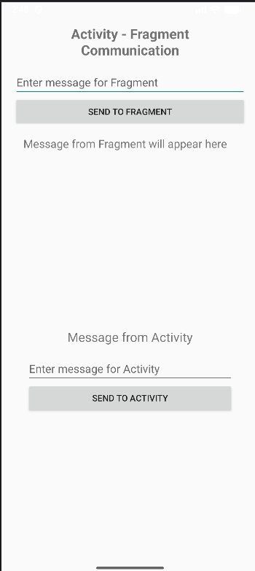

PRACTICAL 3

Basic Layout Management
1. Develop an Android application using LinearLayout (Horizontal and Vertical) to design structured UI.
activity_main.xml
<?xml version="1.0" encoding="utf-8"?>
<LinearLayout xmlns:android="http://schemas.android.com/apk/res/android"
android:layout_width="match_parent"
android:layout_height="match_parent"
android:orientation="vertical"
android:padding="20dp">
<TextView
android:layout_width="match_parent"
android:layout_height="wrap_content"
android:text="Student Registration"
android:textSize="26sp"
android:textStyle="bold"
android:gravity="center"
android:padding="15dp" />
<EditText
android:id="@+id/etName"
android:layout_width="match_parent"
android:layout_height="wrap_content"
android:hint="Enter Student Name"
android:inputType="text" />
<EditText
android:id="@+id/etCourse"
android:layout_width="match_parent"
android:layout_height="wrap_content"
android:hint="Enter Course"
android:inputType="text" />
<LinearLayout
android:layout_width="match_parent"
android:layout_height="wrap_content"
android:orientation="horizontal"
android:gravity="center"
android:layout_marginTop="20dp">
<Button
android:id="@+id/btnSubmit"
android:layout_width="0dp"
android:layout_height="wrap_content"
android:layout_weight="1"
android:text="Submit" />
<Button
android:id="@+id/btnClear"
android:layout_width="0dp"
android:layout_height="wrap_content"
android:layout_weight="1"
android:text="Clear" />
</LinearLayout>
<TextView
android:id="@+id/tvResult"
android:layout_width="match_parent"
android:layout_height="wrap_content"
android:text="Result will appear here"
android:textSize="18sp"
android:gravity="center"
android:padding="20dp" />
</LinearLayout>

MainActivity.kt
package com.example.practical7
import android.os.Bundle
import android.widget.Button
import android.widget.EditText
import android.widget.TextView
import androidx.appcompat.app.AppCompatActivity
class MainActivity : AppCompatActivity() {
override fun onCreate(savedInstanceState: Bundle?) {
super.onCreate(savedInstanceState)
setContentView(R.layout.activity_main)
val etName = findViewById<EditText>(R.id.etName)
val etCourse = findViewById<EditText>(R.id.etCourse)
val btnSubmit = findViewById<Button>(R.id.btnSubmit)
val btnClear = findViewById<Button>(R.id.btnClear)
val tvResult = findViewById<TextView>(R.id.tvResult)
btnSubmit.setOnClickListener {
val name = etName.text.toString()
val course = etCourse.text.toString()
tvResult.text =
"Student Name: $name\nCourse: $course"
}
btnClear.setOnClickListener {
etName.text.clear()
etCourse.text.clear()
tvResult.text = "Result will appear here"
}
}
}

Output:-
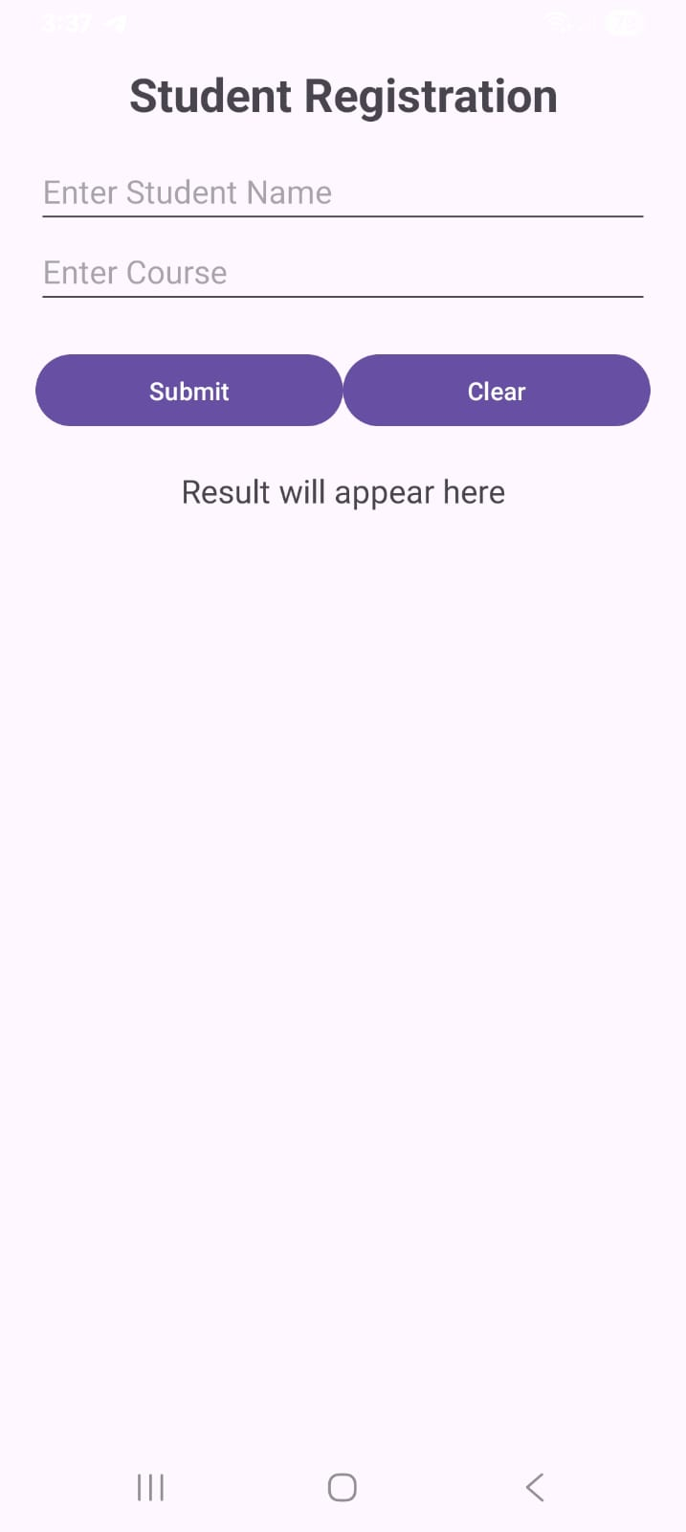
2. Develop an Android application using RelativeLayout to align UI components dynamically.

activity_main.xml
<?xml version="1.0" encoding="utf-8"?>
<RelativeLayout xmlns:android="http://schemas.android.com/apk/res/android"
android:layout_width="match_parent"
android:layout_height="match_parent"
android:padding="20dp">
<TextView
android:id="@+id/tvTitle"
android:layout_width="wrap_content"
android:layout_height="wrap_content"
android:text="Login Form"
android:textSize="28sp"
android:textStyle="bold"
android:layout_centerHorizontal="true"
android:layout_alignParentTop="true" />
<EditText
android:id="@+id/etUsername"
android:layout_width="match_parent"
android:layout_height="wrap_content"
android:hint="Enter Username"
android:inputType="text"
android:layout_below="@id/tvTitle"
android:layout_marginTop="40dp" />
<EditText
android:id="@+id/etPassword"
android:layout_width="match_parent"
android:layout_height="wrap_content"
android:hint="Enter Password"
android:inputType="textPassword"
android:layout_below="@id/etUsername"
android:layout_marginTop="15dp" />
<Button
android:id="@+id/btnLogin"
android:layout_width="wrap_content"
android:layout_height="wrap_content"
android:text="Login"
android:layout_below="@id/etPassword"
android:layout_centerHorizontal="true"
android:layout_marginTop="20dp" />
<TextView
android:id="@+id/tvResult"
android:layout_width="match_parent"
android:layout_height="wrap_content"
android:text="Login result will appear here"
android:textSize="18sp"
android:gravity="center"
android:layout_below="@id/btnLogin"
android:layout_marginTop="25dp" />
</RelativeLayout>

MainActivity.kt
package com.example.practical8
import android.os.Bundle
import android.widget.Button
import android.widget.EditText
import android.widget.TextView
import androidx.appcompat.app.AppCompatActivity
class MainActivity : AppCompatActivity() {
override fun onCreate(savedInstanceState: Bundle?) {
super.onCreate(savedInstanceState)
setContentView(R.layout.activity_main)
val etUsername = findViewById<EditText>(R.id.etUsername)
val etPassword = findViewById<EditText>(R.id.etPassword)
val btnLogin = findViewById<Button>(R.id.btnLogin)
val tvResult = findViewById<TextView>(R.id.tvResult)
btnLogin.setOnClickListener {
val username = etUsername.text.toString()
val password = etPassword.text.toString()
if (username.isNotEmpty() && password.isNotEmpty()) {
tvResult.text = "Login Successful\nWelcome $username"
} else {
tvResult.text = "Please enter username and password"
}
}
}
}

Output:-
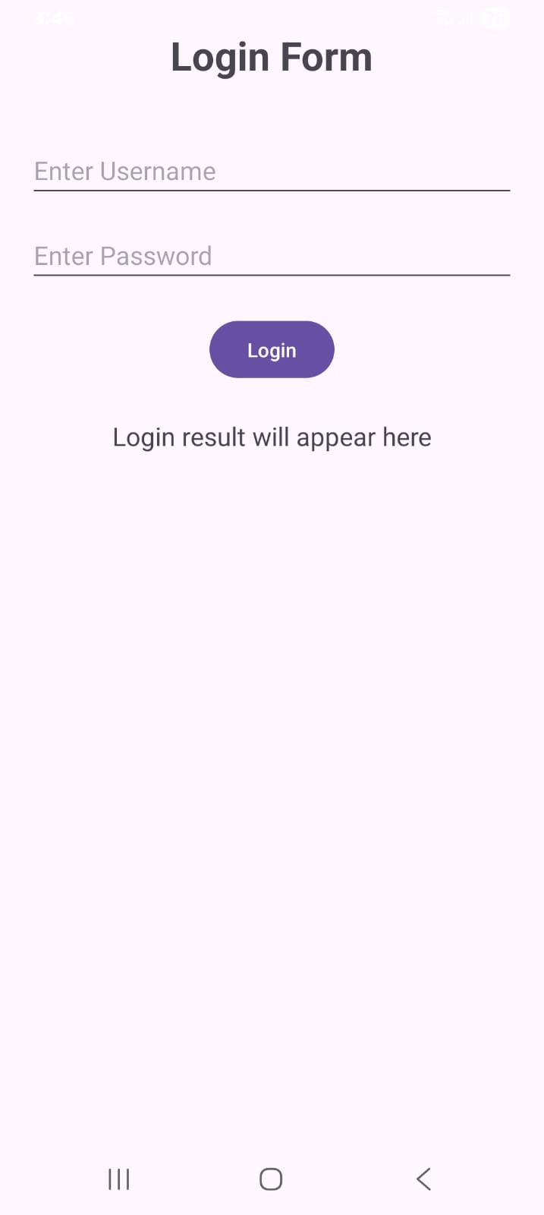

3. Develop an Android application using TableLayout to design a structured Login/Registration Form.
activity_main.xml
<?xml version="1.0" encoding="utf-8"?>
<TableLayout xmlns:android="http://schemas.android.com/apk/res/android"
android:layout_width="match_parent"
android:layout_height="match_parent"
android:padding="20dp"
android:stretchColumns="1">
<TableRow
android:layout_width="match_parent"
android:layout_height="wrap_content">
<TextView
android:layout_width="wrap_content"
android:layout_height="wrap_content"
android:layout_span="2"
android:text="Registration Form"
android:textSize="26sp"
android:textStyle="bold"
android:gravity="center"
android:padding="15dp" />
</TableRow>
<TableRow
android:layout_width="match_parent"
android:layout_height="wrap_content"
android:paddingTop="10dp">
<TextView
android:layout_width="wrap_content"
android:layout_height="wrap_content"
android:text="Name:"
android:textSize="17sp"
android:padding="8dp" />
<EditText
android:id="@+id/etName"
android:layout_width="match_parent"
android:layout_height="wrap_content"
android:hint="Enter name"
android:inputType="text" />
</TableRow>
<TableRow
android:layout_width="match_parent"
android:layout_height="wrap_content">
<TextView
android:layout_width="wrap_content"
android:layout_height="wrap_content"
android:text="Email:"
android:textSize="17sp"
android:padding="8dp" />
<EditText
android:id="@+id/etEmail"
android:layout_width="match_parent"
android:layout_height="wrap_content"
android:hint="Enter email"
android:inputType="textEmailAddress" />
</TableRow>
<TableRow
android:layout_width="match_parent"
android:layout_height="wrap_content">
<TextView
android:layout_width="wrap_content"
android:layout_height="wrap_content"
android:text="Password:"
android:textSize="17sp"
android:padding="8dp" />
<EditText
android:id="@+id/etPassword"
android:layout_width="match_parent"
android:layout_height="wrap_content"
android:hint="Enter password"
android:inputType="textPassword" />
</TableRow>
<TableRow
android:layout_width="match_parent"
android:layout_height="wrap_content">
<TextView
android:layout_width="wrap_content"
android:layout_height="wrap_content"
android:text="Course:"
android:textSize="17sp"
android:padding="8dp" />
<EditText
android:id="@+id/etCourse"
android:layout_width="match_parent"
android:layout_height="wrap_content"
android:hint="Enter course"
android:inputType="text" />
</TableRow>
<TableRow
android:layout_width="match_parent"
android:layout_height="wrap_content"
android:gravity="center"
android:paddingTop="20dp">
<Button
android:id="@+id/btnRegister"
android:layout_width="wrap_content"
android:layout_height="wrap_content"
android:text="Register" />
<Button
android:id="@+id/btnClear"
android:layout_width="wrap_content"
android:layout_height="wrap_content"
android:text="Clear" />
</TableRow>
<TableRow
android:layout_width="match_parent"
android:layout_height="wrap_content">
<TextView
android:id="@+id/tvResult"
android:layout_width="match_parent"
android:layout_height="wrap_content"
android:layout_span="2"
android:text="Registration result will appear here"
android:textSize="17sp"
android:gravity="center"
android:padding="20dp" />
</TableRow>
</TableLayout>

MainActivity.kt
package com.example.practical9
import android.os.Bundle
import android.widget.Button
import android.widget.EditText
import android.widget.TextView
import androidx.appcompat.app.AppCompatActivity
class MainActivity : AppCompatActivity() {
override fun onCreate(savedInstanceState: Bundle?) {
super.onCreate(savedInstanceState)
setContentView(R.layout.activity_main)
val etName = findViewById<EditText>(R.id.etName)
val etEmail = findViewById<EditText>(R.id.etEmail)
val etPassword = findViewById<EditText>(R.id.etPassword)
val etCourse = findViewById<EditText>(R.id.etCourse)
val btnRegister = findViewById<Button>(R.id.btnRegister)
val btnClear = findViewById<Button>(R.id.btnClear)
val tvResult = findViewById<TextView>(R.id.tvResult)
btnRegister.setOnClickListener {
val name = etName.text.toString()
val email = etEmail.text.toString()
val password = etPassword.text.toString()
val course = etCourse.text.toString()
if (name.isEmpty() ||
email.isEmpty() ||
password.isEmpty() ||
course.isEmpty()
) {
tvResult.text = "Please fill all fields"
} else {
tvResult.text =
"Registration Successful\n\n" +
"Name: $name\n" +
"Email: $email\n" +
"Course: $course"
}
}
btnClear.setOnClickListener {
etName.text.clear()
etEmail.text.clear()
etPassword.text.clear()
etCourse.text.clear()
tvResult.text = "Registration result will appear here"
}
}
}

Output:-
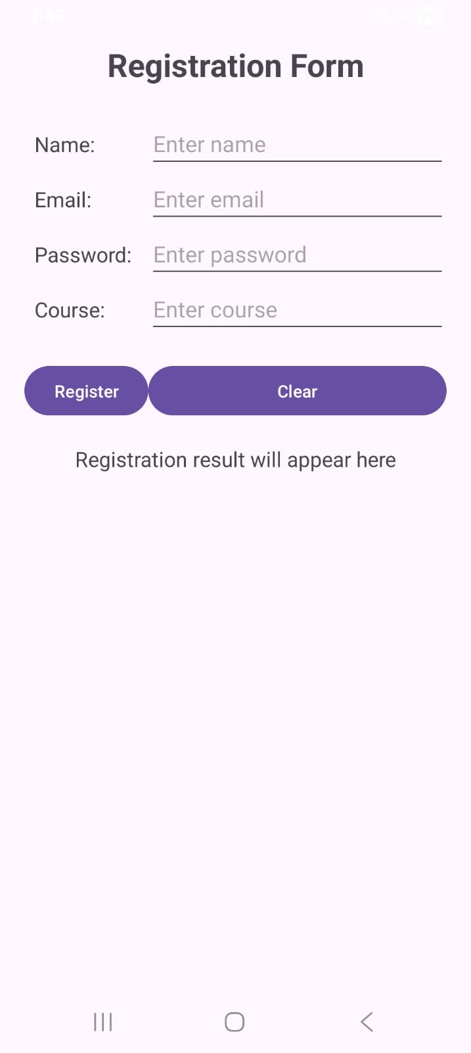

PRACTICAL 4

Advanced Layout and View Handling
1. Develop an Android application using ScrollView to display long scrollable content.
activity_main.xml
<?xml version="1.0" encoding="utf-8"?>
<ScrollView xmlns:android="http://schemas.android.com/apk/res/android"
xmlns:app="http://schemas.android.com/apk/res-auto"
android:layout_width="match_parent"
android:layout_height="match_parent"
android:background="#F5F7FA"
android:fillViewport="true">

<LinearLayout
android:layout_width="match_parent"
android:layout_height="wrap_content"
android:orientation="vertical"
android:padding="16dp">

<!-- Header Banner Card -->
<androidx.cardview.widget.CardView
android:layout_width="match_parent"
android:layout_height="wrap_content"
android:layout_marginBottom="16dp"
app:cardCornerRadius="12dp"
app:cardElevation="4dp"
app:cardBackgroundColor="#1976D2">

<LinearLayout
android:layout_width="match_parent"
android:layout_height="wrap_content"
android:orientation="vertical"
android:padding="20dp"
android:gravity="center">

<TextView
android:layout_width="match_parent"
android:layout_height="wrap_content"
android:text="Android Application Development"
android:textSize="22sp"
android:textStyle="bold"
android:textColor="#FFFFFF"
android:gravity="center" />

<TextView
android:layout_width="match_parent"
android:layout_height="wrap_content"
android:text="Practical 4: Advanced Scrollable Layout"
android:textSize="13sp"
android:textColor="#E3F2FD"
android:gravity="center"
android:layout_marginTop="4dp" />

</LinearLayout>
</androidx.cardview.widget.CardView>

<!-- Section 1: Introduction -->
<androidx.cardview.widget.CardView
android:layout_width="match_parent"
android:layout_height="wrap_content"
android:layout_marginBottom="12dp"
app:cardCornerRadius="10dp"
app:cardElevation="2dp"
app:cardBackgroundColor="#FFFFFF">

<LinearLayout
android:layout_width="match_parent"
android:layout_height="wrap_content"
android:orientation="vertical"
android:padding="16dp">

<TextView
android:layout_width="match_parent"
android:layout_height="wrap_content"
android:text="💡 Introduction"
android:textSize="18sp"
android:textStyle="bold"
android:textColor="#0D47A1" />

<TextView
android:layout_width="match_parent"
android:layout_height="wrap_content"
android:text="Android is an open-source mobile operating system developed for smartphones, tablets, televisions and other devices. Android applications are mainly developed using Android Studio."
android:textSize="15sp"
android:textColor="#424242"
android:layout_marginTop="8dp"
android:lineSpacingExtra="4dp" />

</LinearLayout>
</androidx.cardview.widget.CardView>

<!-- Section 2: Features of Android -->
<androidx.cardview.widget.CardView
android:layout_width="match_parent"
android:layout_height="wrap_content"
android:layout_marginBottom="12dp"
app:cardCornerRadius="10dp"
app:cardElevation="2dp"
app:cardBackgroundColor="#FFFFFF">

<LinearLayout
android:layout_width="match_parent"
android:layout_height="wrap_content"
android:orientation="vertical"
android:padding="16dp">

<TextView
android:layout_width="match_parent"
android:layout_height="wrap_content"
android:text="⚡ Features of Android"
android:textSize="18sp"
android:textStyle="bold"
android:textColor="#0D47A1" />

<TextView
android:layout_width="match_parent"
android:layout_height="wrap_content"
android:text="1. Open-source platform&#10;&#10;2. Supports multiple devices&#10;&#10;3. Rich user interface&#10;&#10;4. Supports multimedia&#10;&#10;5. Database connectivity&#10;&#10;6. Internet and networking support&#10;&#10;7. Notifications and background services&#10;&#10;8. Security and permission management"
android:textSize="15sp"
android:textColor="#424242"
android:layout_marginTop="8dp"
android:lineSpacingExtra="4dp" />

</LinearLayout>
</androidx.cardview.widget.CardView>

<!-- Section 3: Android Components -->
<androidx.cardview.widget.CardView
android:layout_width="match_parent"
android:layout_height="wrap_content"
android:layout_marginBottom="12dp"
app:cardCornerRadius="10dp"
app:cardElevation="2dp"
app:cardBackgroundColor="#FFFFFF">

<LinearLayout
android:layout_width="match_parent"
android:layout_height="wrap_content"
android:orientation="vertical"
android:padding="16dp">

<TextView
android:layout_width="match_parent"
android:layout_height="wrap_content"
android:text="🧩 Android Components"
android:textSize="18sp"
android:textStyle="bold"
android:textColor="#0D47A1" />

<TextView
android:layout_width="match_parent"
android:layout_height="wrap_content"
android:text="The major Android application components are Activities, Services, Broadcast Receivers and Content Providers. Activities provide the user interface, Services perform background operations, Broadcast Receivers respond to system events, and Content Providers manage and share application data."
android:textSize="15sp"
android:textColor="#424242"
android:layout_marginTop="8dp"
android:lineSpacingExtra="4dp" />

</LinearLayout>
</androidx.cardview.widget.CardView>

<!-- Section 4: Advantages -->
<androidx.cardview.widget.CardView
android:layout_width="match_parent"
android:layout_height="wrap_content"
android:layout_marginBottom="24dp"
app:cardCornerRadius="10dp"
app:cardElevation="2dp"
app:cardBackgroundColor="#FFFFFF">

<LinearLayout
android:layout_width="match_parent"
android:layout_height="wrap_content"
android:orientation="vertical"
android:padding="16dp">

<TextView
android:layout_width="match_parent"
android:layout_height="wrap_content"
android:text="🚀 Advantages"
android:textSize="18sp"
android:textStyle="bold"
android:textColor="#0D47A1" />

<TextView
android:layout_width="match_parent"
android:layout_height="wrap_content"
android:text="Android provides a flexible platform for developing mobile applications. It supports different screen sizes, multimedia features, databases, networking, sensors and many other technologies. ScrollView allows users to view content that is larger than the available screen size."
android:textSize="15sp"
android:textColor="#424242"
android:layout_marginTop="8dp"
android:lineSpacingExtra="4dp" />

</LinearLayout>
</androidx.cardview.widget.CardView>

</LinearLayout>
</ScrollView>
MainActivity.kt
package com.example.practical_4

import android.os.Bundle
import androidx.appcompat.app.AppCompatActivity

class MainActivity : AppCompatActivity() {
override fun onCreate(savedInstanceState: Bundle?) {
super.onCreate(savedInstanceState)
setContentView(R.layout.activity_main)
}
}
Output:-
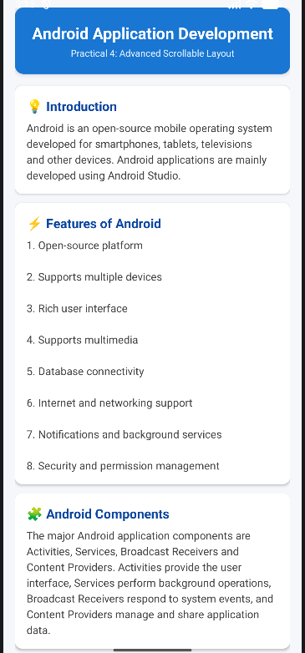
2. Develop an Android application using AbsoluteLayout demonstrating fixed positioning.
activity_main.xml
<?xml version="1.0" encoding="utf-8"?>
<android.widget.AbsoluteLayout
xmlns:android="http://schemas.android.com/apk/res/android"
android:layout_width="match_parent"
android:layout_height="match_parent"
android:background="#FFFFFF">
<TextView
android:id="@+id/tvTitle"
android:layout_width="wrap_content"
android:layout_height="wrap_content"
android:text="Absolute Layout"
android:textSize="26sp"
android:textStyle="bold"
android:textColor="#000000"
android:layout_x="90dp"
android:layout_y="50dp" />
<TextView
android:id="@+id/tvName"
android:layout_width="wrap_content"
android:layout_height="wrap_content"
android:text="Name:"
android:textSize="18sp"
android:textColor="#000000"
android:layout_x="40dp"
android:layout_y="140dp" />
<EditText
android:id="@+id/etName"
android:layout_width="220dp"
android:layout_height="55dp"
android:hint="Enter Name"
android:inputType="text"
android:textSize="16sp"
android:layout_x="110dp"
android:layout_y="125dp" />
<Button
android:id="@+id/btnSubmit"
android:layout_width="140dp"
android:layout_height="wrap_content"
android:text="Submit"
android:layout_x="120dp"
android:layout_y="220dp" />
<TextView
android:id="@+id/tvResult"
android:layout_width="300dp"
android:layout_height="wrap_content"
android:text=""
android:textSize="18sp"
android:textColor="#000000"
android:layout_x="50dp"
android:layout_y="300dp" />
</android.widget.AbsoluteLayout>

MainActivity.kt
package com.example.practical11
import android.os.Bundle
import android.widget.Button
import android.widget.EditText
import android.widget.TextView
import androidx.appcompat.app.AppCompatActivity
class MainActivity : AppCompatActivity() {
override fun onCreate(savedInstanceState: Bundle?) {
super.onCreate(savedInstanceState)
setContentView(R.layout.activity_main)
val etName = findViewById<EditText>(R.id.etName)
val btnSubmit = findViewById<Button>(R.id.btnSubmit)
val tvResult = findViewById<TextView>(R.id.tvResult)
btnSubmit.setOnClickListener {
val name = etName.text.toString()
tvResult.text = "Hello, $name!"
}
}
}

Output:-
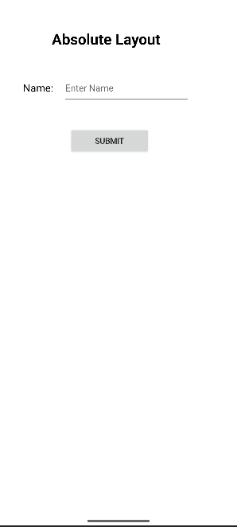

3. Develop an Android application using FrameLayout to overlay UI elements.

Activity_main.xml
<?xml version="1.0" encoding="utf-8"?>
<FrameLayout xmlns:android="http://schemas.android.com/apk/res/android"
android:layout_width="match_parent"
android:layout_height="match_parent">

<ImageView
android:id="@+id/imgBackground"
android:layout_width="match_parent"
android:layout_height="match_parent"
android:src="@drawable/android_image"
android:scaleType="centerCrop"
android:contentDescription="Background Image" />

<TextView
android:id="@+id/tvTitle"
android:layout_width="wrap_content"
android:layout_height="wrap_content"
android:layout_gravity="center"
android:text="Android Application"
android:textSize="26sp"
android:textStyle="bold"
android:textColor="#FFFFFF"
android:padding="15dp" />

<Button
android:id="@+id/btnClick"
android:layout_width="wrap_content"
android:layout_height="wrap_content"
android:layout_gravity="bottom|center_horizontal"
android:layout_marginBottom="50dp"
android:text="Click Me" />

</FrameLayout>
MainActivity.kt
package com.example.practical_4

import android.os.Bundle
import android.widget.Button
import android.widget.Toast
import androidx.appcompat.app.AppCompatActivity

class MainActivity : AppCompatActivity() {
override fun onCreate(savedInstanceState: Bundle?) {
super.onCreate(savedInstanceState)
setContentView(R.layout.activity_main)

val btnClick = findViewById<Button>(R.id.btnClick)

btnClick.setOnClickListener {
Toast.makeText(
this,
"Button Clicked",
Toast.LENGTH_SHORT
).show()
}
}
}
Output:-


PRACTICAL 5

Adapter Based Views
1. Develop an Android application using ListView with ArrayAdapter and implement item click handling.
activity_main.xml
<?xml version="1.0" encoding="utf-8"?>
<LinearLayout xmlns:android="http://schemas.android.com/apk/res/android"
android:layout_width="match_parent"
android:layout_height="match_parent"
android:orientation="vertical"
android:padding="16dp">

<TextView
android:layout_width="match_parent"
android:layout_height="wrap_content"
android:text="Android Topics"
android:textSize="24sp"
android:textStyle="bold"
android:gravity="center"
android:padding="16dp" />
<ListView
android:id="@+id/listView"
android:layout_width="match_parent"
android:layout_height="match_parent" />
</LinearLayout>

MainActivity.kt
package com.example.practical13
import android.os.Bundle import android.widget.ArrayAdapter import android.widget.ListView import android.widget.Toast import androidx.appcompat.app.AppCompatActivity
class MainActivity : AppCompatActivity() {
override fun onCreate(savedInstanceState: Bundle?) {
super.onCreate(savedInstanceState)
setContentView(R.layout.activity_main)
val listView = findViewById<ListView>(R.id.listView)
val topics = arrayOf(
"Activity",
"Intent",
"Fragment",
"Service",
"SQLite Database",
"JSON",
"Broadcast Receiver",
"Notification"
)
val adapter = ArrayAdapter(
this,
android.R.layout.simple_list_item_1,
topics
)
listView.adapter = adapter
listView.setOnItemClickListener { _, _, position, _ ->
val selectedItem = topics[position]
Toast.makeText(
this,
"Selected: $selectedItem",
Toast.LENGTH_SHORT
).show()
}
}
}
Output:-
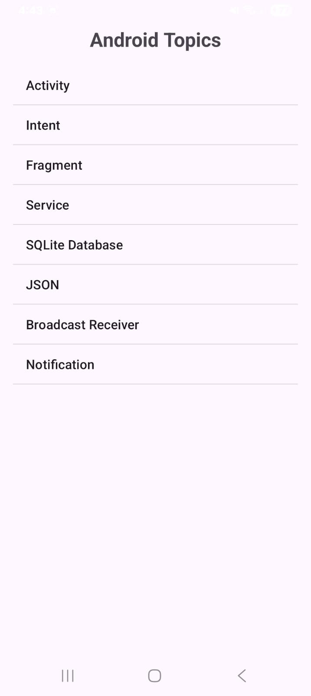
2. Develop an Android application using GridView with Custom Adapter and image selection handling.
activity_main.xml
<?xml version="1.0" encoding="utf-8"?>
<LinearLayout xmlns:android="http://schemas.android.com/apk/res/android"
android:layout_width="match_parent"
android:layout_height="match_parent"
android:orientation="vertical"
android:padding="10dp">
<TextView
android:layout_width="match_parent"
android:layout_height="wrap_content"
android:text="Select an Image"
android:textSize="24sp"
android:textStyle="bold"
android:gravity="center"
android:padding="15dp" />
<GridView
android:id="@+id/gridView"
android:layout_width="match_parent"
android:layout_height="match_parent"
android:numColumns="2"
android:horizontalSpacing="10dp"
android:verticalSpacing="10dp"
android:padding="10dp"
android:gravity="center" />
</LinearLayout>

Create item_grid.xml
Go to: app → res → layout
Right-click layout → New → Layout Resource File
Name it: item_grid.xml

item_grid.xml
<?xml version="1.0" encoding="utf-8"?>
<LinearLayout xmlns:android="http://schemas.android.com/apk/res/android"
android:layout_width="match_parent"
android:layout_height="wrap_content"
android:orientation="vertical"
android:gravity="center"
android:padding="10dp">
<ImageView
android:id="@+id/imageView"
android:layout_width="100dp"
android:layout_height="100dp"
android:scaleType="centerInside"
android:contentDescription="Grid Image" />
<TextView
android:id="@+id/textView"
android:layout_width="wrap_content"
android:layout_height="wrap_content"
android:textSize="16sp"
android:textStyle="bold"
android:gravity="center"
android:padding="5dp" />
</LinearLayout>

Create CustomAdapter.kt
In the same package as your MainActivity.kt, create a new Kotlin class:
Right-click package → New → Kotlin Class/File → CustomAdapter

CustomAdapter.kt
package com.example.practical14
import android.content.Context
import android.view.LayoutInflater
import android.view.View
import android.view.ViewGroup
import android.widget.BaseAdapter
import android.widget.ImageView
import android.widget.TextView
class CustomAdapter(
private val context: Context,
private val images: IntArray,
private val names: Array<String>
) : BaseAdapter() {
override fun getCount(): Int {
return images.size
}
override fun getItem(position: Int): Any {
return images[position]
}
override fun getItemId(position: Int): Long {
return position.toLong()
}
override fun getView(
position: Int,
convertView: View?,
parent: ViewGroup?
): View {
val view = convertView ?: LayoutInflater.from(context)
.inflate(R.layout.item_grid, parent, false)
val imageView = view.findViewById<ImageView>(R.id.imageView)
val textView = view.findViewById<TextView>(R.id.textView)
imageView.setImageResource(images[position])
textView.text = names[position]
return view
}
}

MainActivity.kt
package com.example.practical14
import android.os.Bundle import android.widget.GridView import android.widget.Toast import androidx.appcompat.app.AppCompatActivity
class MainActivity : AppCompatActivity() {
override fun onCreate(savedInstanceState: Bundle?) {
super.onCreate(savedInstanceState)
setContentView(R.layout.activity_main)
val gridView = findViewById<GridView>(R.id.gridView)
val images = intArrayOf(
android.R.drawable.ic_menu_camera,
android.R.drawable.ic_menu_gallery,
android.R.drawable.ic_menu_call,
android.R.drawable.ic_menu_mapmode,
android.R.drawable.ic_menu_search,
android.R.drawable.ic_menu_compass
)
val names = arrayOf(
"Camera",
"Gallery",
"Call",
"Map",
"Search",
"Compass"
)
val adapter = CustomAdapter(
this,
images,
names
)
gridView.adapter = adapter
gridView.setOnItemClickListener { _, _, position, _ ->
Toast.makeText(
this,
"Selected: ${names[position]}",
Toast.LENGTH_SHORT
).show()
}
}
}
Output:-
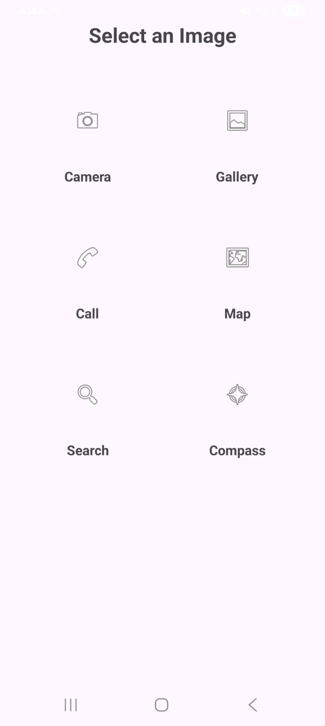
3. Develop an Android application implementing RecyclerView as a modern alternative to ListView.
Open: Gradle Scripts → build.gradle.kts (Module :app)
Inside dependencies { }, add:
implementation("androidx.recyclerview:recyclerview:1.4.0")
Then click Sync Now.

activity_main.xml
<?xml version="1.0" encoding="utf-8"?>
<LinearLayout xmlns:android="http://schemas.android.com/apk/res/android"
android:layout_width="match_parent"
android:layout_height="match_parent"
android:orientation="vertical"
android:padding="16dp">
<TextView
android:layout_width="match_parent"
android:layout_height="wrap_content"
android:text="Android Topics"
android:textSize="24sp"
android:textStyle="bold"
android:gravity="center"
android:padding="16dp" />
<androidx.recyclerview.widget.RecyclerView
android:id="@+id/recyclerView"
android:layout_width="match_parent"
android:layout_height="match_parent" />
</LinearLayout>

Create item_topic.xml
Go to: app → res → layout
Right-click layout → New → Layout Resource File
Name: item_topic.xml

item_topic.xml
<?xml version="1.0" encoding="utf-8"?>

<LinearLayout xmlns:android="http://schemas.android.com/apk/res/android"
android:layout_width="match_parent"
android:layout_height="wrap_content"
android:orientation="vertical"
android:padding="16dp">
<TextView
android:id="@+id/tvTopic"
android:layout_width="match_parent"
android:layout_height="wrap_content"
android:textSize="18sp"
android:textStyle="bold"
android:padding="12dp" />
</LinearLayout>

Create TopicAdapter.kt
Right-click your package:
New → Kotlin Class/File → TopicAdapter
TopicAdapter.kt
package com.example.practical15
import android.view.LayoutInflater
import android.view.View
import android.view.ViewGroup
import android.widget.TextView
import androidx.recyclerview.widget.RecyclerView
class TopicAdapter(
private val topics: Array<String>,
private val onItemClick: (String) -> Unit
) : RecyclerView.Adapter<TopicAdapter.TopicViewHolder>() {
class TopicViewHolder(itemView: View) : RecyclerView.ViewHolder(itemView) {
val tvTopic: TextView = itemView.findViewById(R.id.tvTopic)
}
override fun onCreateViewHolder(
parent: ViewGroup,
viewType: Int
): TopicViewHolder {
val view = LayoutInflater.from(parent.context)
.inflate(R.layout.item_topic, parent, false)
return TopicViewHolder(view)
}
override fun onBindViewHolder(
holder: TopicViewHolder,
position: Int
) {
val topic = topics[position]
holder.tvTopic.text = topic
holder.itemView.setOnClickListener {
onItemClick(topic)
}
}
override fun getItemCount(): Int {
return topics.size
}
}

MainActivity.kt
package com.example.practical15
import android.os.Bundle
import android.widget.Toast
import androidx.appcompat.app.AppCompatActivity
import androidx.recyclerview.widget.LinearLayoutManager
import androidx.recyclerview.widget.RecyclerView
class MainActivity : AppCompatActivity() {
override fun onCreate(savedInstanceState: Bundle?) {
super.onCreate(savedInstanceState)
setContentView(R.layout.activity_main)
val recyclerView = findViewById<RecyclerView>(R.id.recyclerView)
val topics = arrayOf(
"Activity",
"Intent",
"Fragment",
"Service",
"SQLite Database",
"JSON",
"Broadcast Receiver",
"Notification"
)
recyclerView.layoutManager = LinearLayoutManager(this)
val adapter = TopicAdapter(topics) { selectedTopic ->
Toast.makeText(
this,
"Selected: $selectedTopic",
Toast.LENGTH_SHORT
).show()
}
recyclerView.adapter = adapter
}
}
Output:-
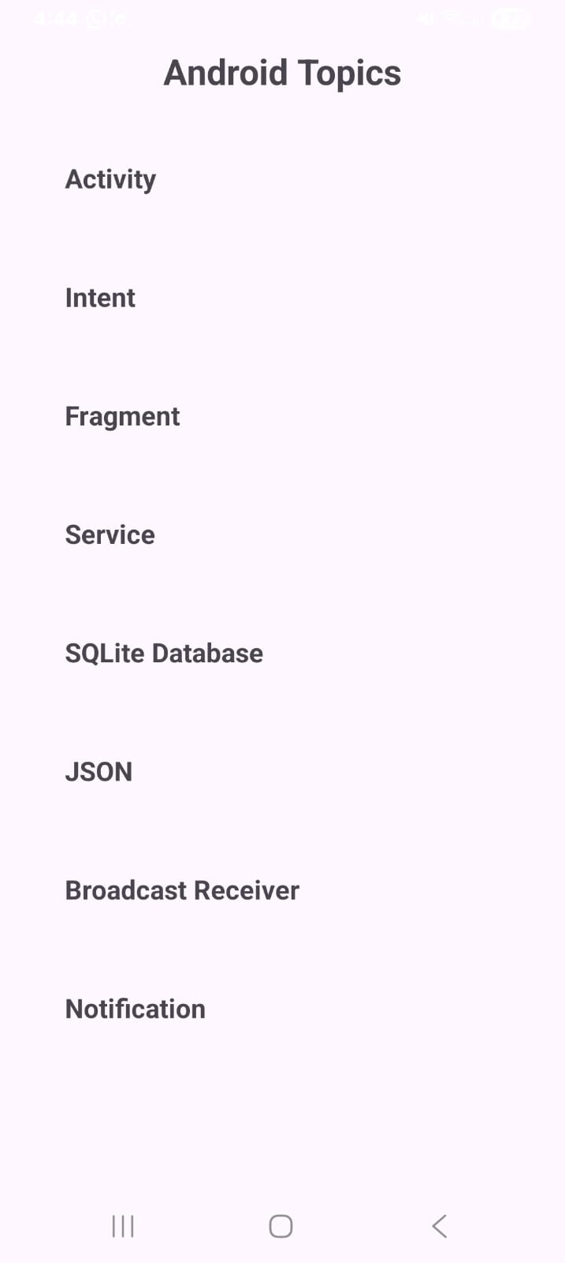

PRACTICAL 6

Menus, Dialogs and UI Interaction
1. Develop an Android application implementing AppBar (Toolbar) and Options Menu.
activity_main.xml
<?xml version="1.0" encoding="utf-8"?>
<LinearLayout xmlns:android="http://schemas.android.com/apk/res/android"
xmlns:app="http://schemas.android.com/apk/res-auto"
android:layout_width="match_parent"
android:layout_height="match_parent"
android:orientation="vertical">
<androidx.appcompat.widget.Toolbar
android:id="@+id/toolbar"
android:layout_width="match_parent"
android:layout_height="?attr/actionBarSize"
android:background="@color/primary_color"
app:title="Android App"
app:titleTextColor="@color/white" />
<TextView
android:id="@+id/tvMessage"
android:layout_width="match_parent"
android:layout_height="match_parent"
android:gravity="center"
android:text="Welcome to Android Application"
android:textSize="22sp"
android:textStyle="bold" />
</LinearLayout>
colors.xml
<?xml version="1.0" encoding="utf-8"?>
<resources>
<color name="primary_color">#3F51B5</color>
<color name="white">#FFFFFFFF</color>
</resources>

Create menu_main.xml
Go to: app → res
Right-click res → New → Android Resource Directory
Select: Resource type: menu
Click OK.
Now right-click the new menu folder:
New → Menu Resource File
Name: menu_main.xml
menu_main.xml
<?xml version="1.0" encoding="utf-8"?>
<menu xmlns:android="http://schemas.android.com/apk/res/android"
xmlns:app="http://schemas.android.com/apk/res-auto">
<item
android:id="@+id/menu_home"
android:title="Home"
app:showAsAction="never" />
<item
android:id="@+id/menu_settings"
android:title="Settings"
app:showAsAction="never" />
<item
android:id="@+id/menu_about"
android:title="About"
app:showAsAction="never" />
</menu>
MainActivity.kt
package com.example.practical16
import android.os.Bundle
import android.view.Menu
import android.view.MenuItem
import android.widget.TextView
import android.widget.Toast
import androidx.appcompat.app.AppCompatActivity
import androidx.appcompat.widget.Toolbar
class MainActivity : AppCompatActivity() {
private lateinit var toolbar: Toolbar
private lateinit var tvMessage: TextView
override fun onCreate(savedInstanceState: Bundle?) {
super.onCreate(savedInstanceState)
setContentView(R.layout.activity_main)
toolbar = findViewById(R.id.toolbar)
tvMessage = findViewById(R.id.tvMessage)
setSupportActionBar(toolbar)
supportActionBar?.title = "Android App"
}
override fun onCreateOptionsMenu(menu: Menu): Boolean {
menuInflater.inflate(R.menu.menu_main, menu)
return true
}
override fun onOptionsItemSelected(item: MenuItem): Boolean {
return when (item.itemId) {
R.id.menu_home -> {
tvMessage.text = "Home Selected"
Toast.makeText(
this,
"Home selected",
Toast.LENGTH_SHORT
).show()
true
}
R.id.menu_settings -> {
tvMessage.text = "Settings Selected"
Toast.makeText(
this,
"Settings selected",
Toast.LENGTH_SHORT
).show()
true
}
R.id.menu_about -> {
tvMessage.text = "About Selected"
Toast.makeText(
this,
"About selected",
Toast.LENGTH_SHORT
).show()
true
}
else -> super.onOptionsItemSelected(item)
}
}
}
Output:-
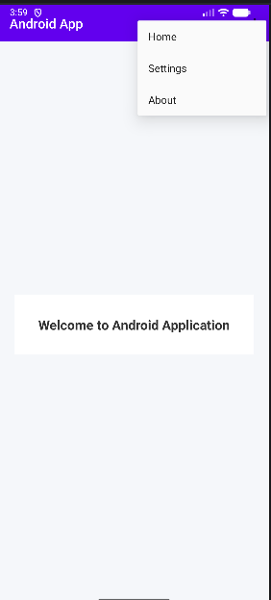

2. Develop an Android application demonstrating AlertDialog and custom DialogFragment.

activity_main.xml
<?xml version="1.0" encoding="utf-8"?>
<LinearLayout xmlns:android="http://schemas.android.com/apk/res/android"
android:layout_width="match_parent"
android:layout_height="match_parent"
android:orientation="vertical"
android:gravity="center"
android:background="#F5F7FA"
android:padding="24dp">

<TextView
android:layout_width="match_parent"
android:layout_height="wrap_content"
android:text="Dialog Demonstration"
android:textSize="24sp"
android:textStyle="bold"
android:textColor="#1F2937"
android:gravity="center"
android:layout_marginBottom="32dp" />

<Button
android:id="@+id/btnAlertDialog"
android:layout_width="match_parent"
android:layout_height="wrap_content"
android:text="Show Standard AlertDialog"
android:textSize="16sp" />

<Button
android:id="@+id/btnCustomDialog"
android:layout_width="match_parent"
android:layout_height="wrap_content"
android:text="Show Custom DialogFragment"
android:textSize="16sp"
android:layout_marginTop="16dp" />

</LinearLayout>
create dialog_custom.xml
Go to: res → layout → New → Layout Resource File
Name it: dialog_custom.xml

dialog_custom.xml
<?xml version="1.0" encoding="utf-8"?>
<LinearLayout xmlns:android="http://schemas.android.com/apk/res/android"
android:layout_width="match_parent"
android:layout_height="wrap_content"
android:orientation="vertical"
android:background="#FFFFFF"
android:padding="24dp">

<TextView
android:layout_width="match_parent"
android:layout_height="wrap_content"
android:text="Custom Dialog"
android:textSize="22sp"
android:textStyle="bold"
android:textColor="#0F9D58"
android:gravity="center"
android:layout_marginBottom="16dp" />

<EditText
android:id="@+id/etName"
android:layout_width="match_parent"
android:layout_height="wrap_content"
android:hint="Enter your name"
android:inputType="text"
android:textSize="16sp"
android:layout_marginBottom="20dp" />

<Button
android:id="@+id/btnSubmit"
android:layout_width="match_parent"
android:layout_height="wrap_content"
android:text="Submit"
android:textSize="16sp" />

</LinearLayout>
Create CustomDialogFragment.kt
Go to your package: New → Kotlin Class/File → CustomDialogFragment

CustomDialogFragment.kt
package com.example.practical17
import android.app.Dialog
import android.os.Bundle
import android.view.LayoutInflater
import android.view.View
import android.widget.Button
import android.widget.EditText
import android.widget.Toast
import androidx.appcompat.app.AlertDialog
import androidx.fragment.app.DialogFragment
class CustomDialogFragment : DialogFragment() {
override fun onCreateDialog(savedInstanceState: Bundle?): Dialog {
val view = LayoutInflater.from(requireContext())
.inflate(R.layout.dialog_custom, null)
val etName = view.findViewById<EditText>(R.id.etName)
val btnSubmit = view.findViewById<Button>(R.id.btnSubmit)
val dialog = AlertDialog.Builder(requireContext())
.setView(view)
.create()
btnSubmit.setOnClickListener {
val name = etName.text.toString()
if (name.isEmpty()) {
Toast.makeText(
requireContext(),
"Please enter your name",
Toast.LENGTH_SHORT
).show()
} else {
Toast.makeText(
requireContext(),
"Hello $name",
Toast.LENGTH_SHORT
).show()
dialog.dismiss()
}
}
return dialog
}
}

MainActivity.kt
package com.example.practical2
import android.os.Bundle
import android.widget.Button
import androidx.appcompat.app.AlertDialog
import androidx.appcompat.app.AppCompatActivity
class MainActivity : AppCompatActivity() {
override fun onCreate(savedInstanceState: Bundle?) {
super.onCreate(savedInstanceState)
setContentView(R.layout.activity_main)
val btnAlertDialog = findViewById<Button>(R.id.btnAlertDialog)
val btnCustomDialog = findViewById<Button>(R.id.btnCustomDialog)
btnAlertDialog.setOnClickListener {
AlertDialog.Builder(this)
.setTitle("Alert Dialog")
.setMessage("Do you want to continue?")
.setPositiveButton("Yes") { dialog, _ ->
dialog.dismiss()
}
.setNegativeButton("No") { dialog, _ ->
dialog.dismiss()
}
.show()
}
btnCustomDialog.setOnClickListener {
val customDialog = CustomDialogFragment()
customDialog.show(
supportFragmentManager,
"CustomDialog"
)
}
}
}

Output:-

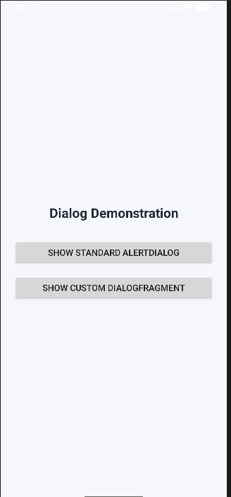

3. Develop an Android application implementing contextual menus and popup menus.

activity_main.xml
<?xml version="1.0" encoding="utf-8"?>
<LinearLayout xmlns:android="http://schemas.android.com/apk/res/android"
android:layout_width="match_parent"
android:layout_height="match_parent"
android:orientation="vertical"
android:gravity="center"
android:padding="25dp">
<TextView
android:id="@+id/tvContext"
android:layout_width="match_parent"
android:layout_height="wrap_content"
android:text="Long Press This Text"
android:textSize="22sp"
android:textStyle="bold"
android:gravity="center"
android:padding="25dp" />
<Button
android:id="@+id/btnPopup"
android:layout_width="wrap_content"
android:layout_height="wrap_content"
android:text="Show Popup Menu"
android:layout_marginTop="30dp" />
<TextView
android:id="@+id/tvResult"
android:layout_width="match_parent"
android:layout_height="wrap_content"
android:text="Selected option will appear here"
android:textSize="18sp"
android:gravity="center"
android:padding="25dp" />
</LinearLayout>

Create Popup Menu XML
res → Right Click → New → Android Resource Directory → Resource type: menu
Then: Right Click menu → New → Menu Resource File
Name: popup_menu.xml

popup_menu.xml
<?xml version="1.0" encoding="utf-8"?>
<menu xmlns:android="http://schemas.android.com/apk/res/android">
<item
android:id="@+id/popup_edit"
android:title="Edit" />
<item
android:id="@+id/popup_delete"
android:title="Delete" />
<item
android:id="@+id/popup_share"
android:title="Share" />
</menu>
MainActivity.kt
package com.example.practical18
import android.os.Bundle
import android.view.ActionMode
import android.view.Menu
import android.view.MenuItem
import android.view.View
import android.widget.Button
import android.widget.TextView
import android.widget.Toast
import androidx.appcompat.app.AppCompatActivity
import androidx.appcompat.widget.PopupMenu
class MainActivity : AppCompatActivity() {
private lateinit var tvContext: TextView
private lateinit var btnPopup: Button
private lateinit var tvResult: TextView
override fun onCreate(savedInstanceState: Bundle?) {
super.onCreate(savedInstanceState)
setContentView(R.layout.activity_main)
tvContext = findViewById(R.id.tvContext)
btnPopup = findViewById(R.id.btnPopup)
tvResult = findViewById(R.id.tvResult)
tvContext.setOnLongClickListener {
startActionMode(contextualCallback)
true
}
btnPopup.setOnClickListener {
showPopupMenu(btnPopup)
}
}
private val contextualCallback = object : ActionMode.Callback {
override fun onCreateActionMode(
mode: ActionMode?,
menu: Menu?
): Boolean {
menu?.add(0, 1, 0, "Edit")
menu?.add(0, 2, 1, "Delete")
menu?.add(0, 3, 2, "Share")
return true
}
override fun onPrepareActionMode(
mode: ActionMode?,
menu: Menu?
): Boolean {
return false
}
override fun onActionItemClicked(
mode: ActionMode?,
item: MenuItem?
): Boolean {
return when (item?.itemId) {
1 -> {
tvResult.text = "Contextual Menu: Edit selected"
Toast.makeText(
this@MainActivity,
"Edit selected",
Toast.LENGTH_SHORT
).show()
mode?.finish()
true
}
2 -> {
tvResult.text = "Contextual Menu: Delete selected"
Toast.makeText(
this@MainActivity,
"Delete selected",
Toast.LENGTH_SHORT
).show()
mode?.finish()
true
}
3 -> {
tvResult.text = "Contextual Menu: Share selected"
Toast.makeText(
this@MainActivity,
"Share selected",
Toast.LENGTH_SHORT
).show()
mode?.finish()
true
}
else -> false
}
}
override fun onDestroyActionMode(mode: ActionMode?) {
}
}
private fun showPopupMenu(view: View) {
val popupMenu = PopupMenu(this, view)
popupMenu.menuInflater.inflate(
R.menu.popup_menu,
popupMenu.menu
)
popupMenu.setOnMenuItemClickListener { item ->
when (item.itemId) {
R.id.popup_edit -> {
tvResult.text = "Popup Menu: Edit selected"
Toast.makeText(
this,
"Edit selected",
Toast.LENGTH_SHORT
).show()
true
}
R.id.popup_delete -> {
tvResult.text = "Popup Menu: Delete selected"
Toast.makeText(
this,
"Delete selected",
Toast.LENGTH_SHORT
).show()
true
}
R.id.popup_share -> {
tvResult.text = "Popup Menu: Share selected"
Toast.makeText(
this,
"Share selected",
Toast.LENGTH_SHORT
).show()
true
}
else -> false
}
}
popupMenu.show()
}
}

Output:-
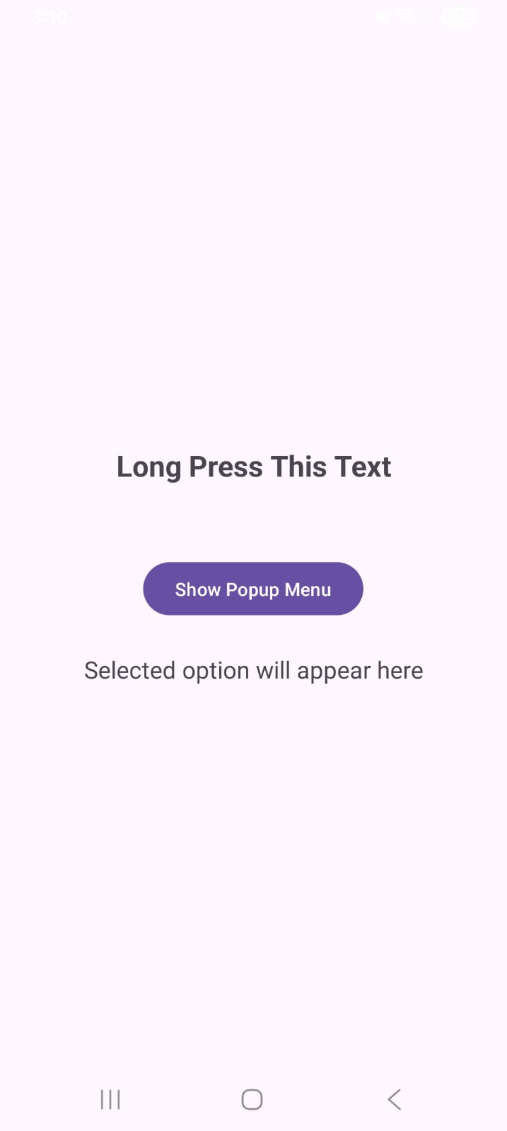

PRACTICAL 7

Intents, Events and Listeners
1. Develop an Android application implementing Explicit and Implicit Intents.
activity_main.xml
<?xml version="1.0" encoding="utf-8"?>
<LinearLayout xmlns:android="http://schemas.android.com/apk/res/android"
android:layout_width="match_parent"
android:layout_height="match_parent"
android:orientation="vertical"
android:gravity="center"
android:padding="25dp">
<TextView
android:layout_width="match_parent"
android:layout_height="wrap_content"
android:text="Intent Demonstration"
android:textSize="26sp"
android:textStyle="bold"
android:gravity="center"
android:padding="20dp" />
<Button
android:id="@+id/btnExplicit"
android:layout_width="match_parent"
android:layout_height="wrap_content"
android:text="Explicit Intent" />
<Button
android:id="@+id/btnImplicit"
android:layout_width="match_parent"
android:layout_height="wrap_content"
android:text="Implicit Intent"
android:layout_marginTop="15dp" />
</LinearLayout>

Create activity_second.xml
Go to: res → layout → Right Click → New → Layout Resource File
Name: activity_second.xml

activity_second.xml
<?xml version="1.0" encoding="utf-8"?>
<LinearLayout xmlns:android="http://schemas.android.com/apk/res/android"
android:layout_width="match_parent"
android:layout_height="match_parent"
android:orientation="vertical"
android:gravity="center"
android:padding="25dp">
<TextView
android:id="@+id/tvSecond"
android:layout_width="match_parent"
android:layout_height="wrap_content"
android:text="This is Second Activity"
android:textSize="26sp"
android:textStyle="bold"
android:gravity="center" />
<Button
android:id="@+id/btnBack"
android:layout_width="wrap_content"
android:layout_height="wrap_content"
android:text="Back"
android:layout_marginTop="25dp" />
</LinearLayout>

Create SecondActivity.kt
Go to your package: Right Click → New → Kotlin Class/File
Name: SecondActivity

SecondActivity.kt
package com.example.practical19
import android.os.Bundle
import android.widget.Button
import androidx.appcompat.app.AppCompatActivity
class SecondActivity : AppCompatActivity() {
override fun onCreate(savedInstanceState: Bundle?) {
super.onCreate(savedInstanceState)
setContentView(R.layout.activity_second)
val btnBack = findViewById<Button>(R.id.btnBack)
btnBack.setOnClickListener {
finish()
}
}
}

Add SecondActivity to AndroidManifest.xml
Open: app → manifests → AndroidManifest.xml
Inside the <application> tag, add:
<activity
android:name=".SecondActivity"
android:exported="false" />

MainActivity.kt
package com.example.practical19
import android.content.Intent
import android.net.Uri
import android.os.Bundle
import android.widget.Button
import androidx.appcompat.app.AppCompatActivity
class MainActivity : AppCompatActivity() {
override fun onCreate(savedInstanceState: Bundle?) {
super.onCreate(savedInstanceState)
setContentView(R.layout.activity_main)
val btnExplicit = findViewById<Button>(R.id.btnExplicit)
val btnImplicit = findViewById<Button>(R.id.btnImplicit)
btnExplicit.setOnClickListener {
val intent = Intent(
this,
SecondActivity::class.java
)
startActivity(intent)
}
btnImplicit.setOnClickListener {
val intent = Intent(
Intent.ACTION_VIEW,
Uri.parse("https://www.google.com")
)
startActivity(intent)
}
}
}

Output:-
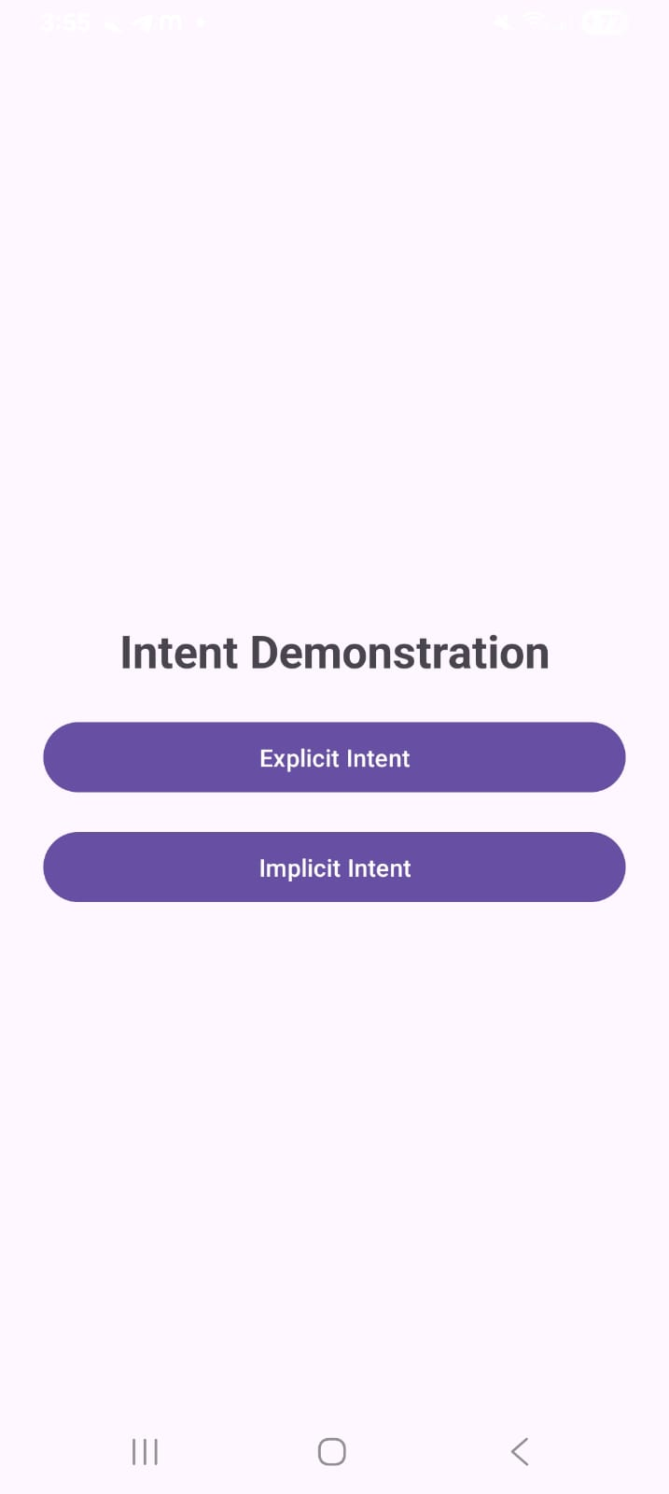

2. Develop an Android application demonstrating Event Handling using Listeners (OnClick, OnLongClick, etc.).

activity_main.xml
<?xml version="1.0" encoding="utf-8"?>
<LinearLayout xmlns:android="http://schemas.android.com/apk/res/android"
android:layout_width="match_parent"
android:layout_height="match_parent"
android:orientation="vertical"
android:gravity="center"
android:padding="25dp">
<TextView
android:id="@+id/tvTitle"
android:layout_width="match_parent"
android:layout_height="wrap_content"
android:text="Event Handling Demo"
android:textSize="26sp"
android:textStyle="bold"
android:gravity="center"
android:padding="20dp" />
<Button
android:id="@+id/btnClick"
android:layout_width="match_parent"
android:layout_height="wrap_content"
android:text="Click Me" />
<Button
android:id="@+id/btnLongClick"
android:layout_width="match_parent"
android:layout_height="wrap_content"
android:text="Long Press Me"
android:layout_marginTop="15dp" />
<EditText
android:id="@+id/etName"
android:layout_width="match_parent"
android:layout_height="wrap_content"
android:hint="Enter your name"
android:layout_marginTop="15dp"
android:inputType="text" />
<TextView
android:id="@+id/tvResult"
android:layout_width="match_parent"
android:layout_height="wrap_content"
android:text="Perform an event to see the result"
android:textSize="18sp"
android:gravity="center"
android:padding="25dp" />
</LinearLayout>

MainActivity.kt
package com.example.practical5
import android.os.Bundle
import android.view.View
import android.widget.Button
import android.widget.EditText
import android.widget.TextView
import android.widget.Toast
import androidx.appcompat.app.AppCompatActivity
class MainActivity : AppCompatActivity() {
override fun onCreate(savedInstanceState: Bundle?) {
super.onCreate(savedInstanceState)
setContentView(R.layout.activity_main)
val btnClick = findViewById<Button>(R.id.btnClick)
val btnLongClick = findViewById<Button>(R.id.btnLongClick)
val etName = findViewById<EditText>(R.id.etName)
val tvResult = findViewById<TextView>(R.id.tvResult)
btnClick.setOnClickListener {
tvResult.text = "OnClick Event: Button clicked"
Toast.makeText(
this,
"Button clicked",
Toast.LENGTH_SHORT
).show()
}
btnLongClick.setOnLongClickListener {
tvResult.text = "OnLongClick Event: Button long pressed"
Toast.makeText(
this,
"Button long pressed",
Toast.LENGTH_SHORT
).show()
true
}
etName.setOnFocusChangeListener { _, hasFocus ->
if (hasFocus) {
tvResult.text = "OnFocusChange Event: EditText focused"
} else {
val name = etName.text.toString()
tvResult.text =
"OnFocusChange Event: Focus lost\n$name"
}
}
}
}

Output:-
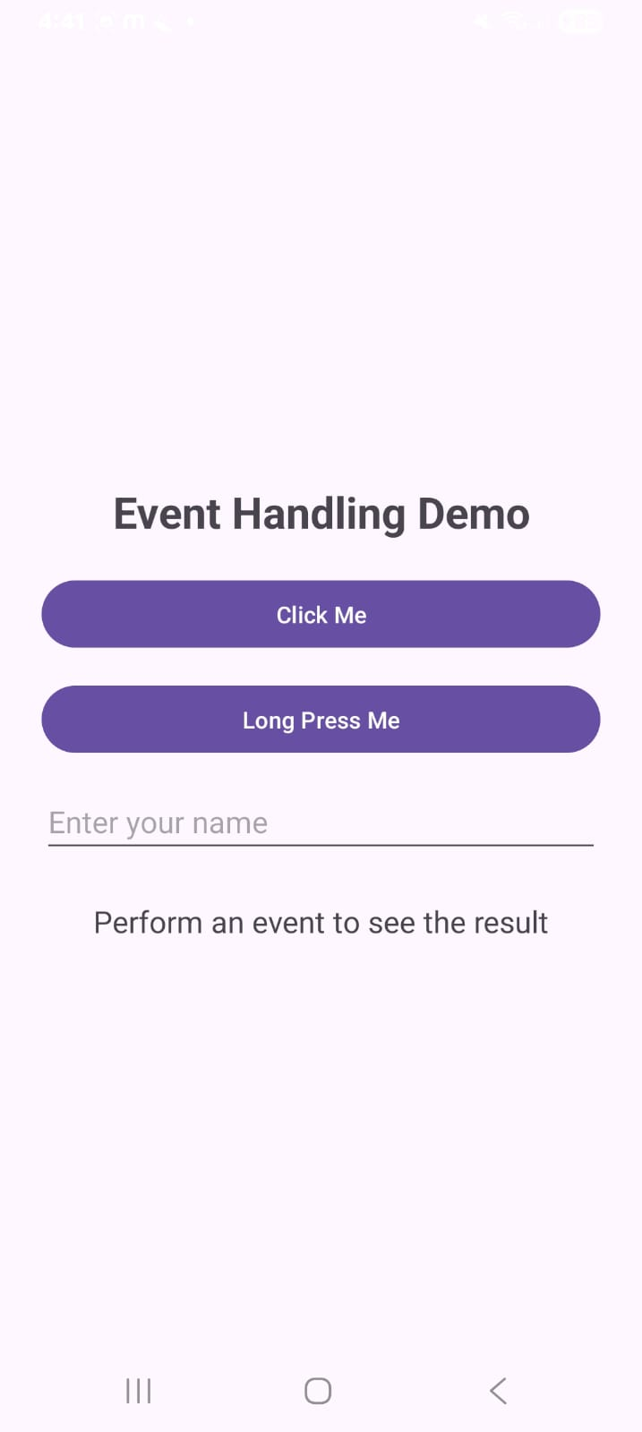

3. Develop an Android application using Adapters to populate Spinner or ListView dynamically.

activity_main.xml
<?xml version="1.0" encoding="utf-8"?>
<LinearLayout xmlns:android="http://schemas.android.com/apk/res/android"
android:layout_width="match_parent"
android:layout_height="match_parent"
android:orientation="vertical"
android:gravity="center"
android:padding="25dp">
<TextView
android:id="@+id/tvTitle"
android:layout_width="match_parent"
android:layout_height="wrap_content"
android:text="Select Your Course"
android:textSize="26sp"
android:textStyle="bold"
android:gravity="center"
android:padding="20dp" />
<Spinner
android:id="@+id/spinnerCourse"
android:layout_width="match_parent"
android:layout_height="wrap_content"
android:layout_marginTop="20dp" />
<Button
android:id="@+id/btnAdd"
android:layout_width="wrap_content"
android:layout_height="wrap_content"
android:text="Add Course"
android:layout_marginTop="25dp" />
<TextView
android:id="@+id/tvResult"
android:layout_width="match_parent"
android:layout_height="wrap_content"
android:text="Selected course will appear here"
android:textSize="18sp"
android:gravity="center"
android:padding="25dp" />
</LinearLayout>

MainActivity.kt
package com.example.practical6
import android.os.Bundle
import android.widget.ArrayAdapter
import android.widget.Button
import android.widget.Spinner
import android.widget.TextView
import android.widget.Toast
import androidx.appcompat.app.AppCompatActivity
class MainActivity : AppCompatActivity() {
private lateinit var spinnerCourse: Spinner
private lateinit var btnAdd: Button
private lateinit var tvResult: TextView
private val courses = arrayListOf(
"B.Sc. Information Technology",
"BCA",
"B.Sc. Computer Science",
"MCA",
"M.Sc. IT"
)
override fun onCreate(savedInstanceState: Bundle?) {
super.onCreate(savedInstanceState)
setContentView(R.layout.activity_main)
spinnerCourse = findViewById(R.id.spinnerCourse)
btnAdd = findViewById(R.id.btnAdd)
tvResult = findViewById(R.id.tvResult)
val adapter = ArrayAdapter(
this,
android.R.layout.simple_spinner_item,
courses
)
adapter.setDropDownViewResource(
android.R.layout.simple_spinner_dropdown_item
)
spinnerCourse.adapter = adapter
spinnerCourse.setOnItemSelectedListener(
object : android.widget.AdapterView.OnItemSelectedListener {
override fun onItemSelected(
parent: android.widget.AdapterView<*>?,
view: android.view.View?,
position: Int,
id: Long
) {
val selectedCourse = courses[position]
tvResult.text =
"Selected Course: $selectedCourse"
}
override fun onNothingSelected(
parent: android.widget.AdapterView<*>?
) {
tvResult.text = "No course selected"
}
}
)
btnAdd.setOnClickListener {
val newCourse = "Android Development"
if (!courses.contains(newCourse)) {
courses.add(newCourse)
adapter.notifyDataSetChanged()
Toast.makeText(
this,
"Course added successfully",
Toast.LENGTH_SHORT
).show()
}
}
}
}

Output:-
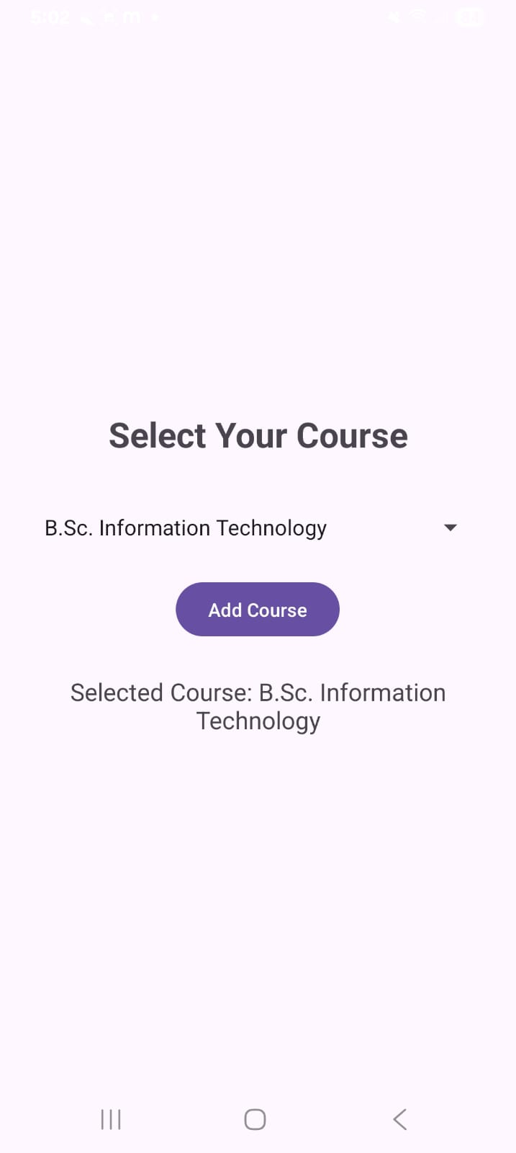
PRACTICAL 8

Services, Notifications and Broadcast Receivers
1. Develop an Android application implementing Started and Bound Services.
activity_main.xml
<?xml version="1.0" encoding="utf-8"?>
<ScrollView xmlns:android="http://schemas.android.com/apk/res/android"
android:layout_width="match_parent"
android:layout_height="match_parent"
android:background="#F5F7FA"
android:fillViewport="true">

<LinearLayout
android:layout_width="match_parent"
android:layout_height="wrap_content"
android:orientation="vertical"
android:padding="20dp">

<!-- Header -->
<LinearLayout
android:layout_width="match_parent"
android:layout_height="wrap_content"
android:orientation="vertical"
android:background="#1976D2"
android:padding="20dp"
android:gravity="center"
android:layout_marginBottom="20dp">

<TextView
android:layout_width="wrap_content"
android:layout_height="wrap_content"
android:text="⚡ Service Control Hub"
android:textSize="22sp"
android:textStyle="bold"
android:textColor="#FFFFFF" />

<TextView
android:layout_width="wrap_content"
android:layout_height="wrap_content"
android:text="Practical 8: Started &amp; Bound Services"
android:textSize="13sp"
android:textColor="#E3F2FD"
android:layout_marginTop="4dp" />
</LinearLayout>

<!-- Status Display -->
<TextView
android:id="@+id/tvResult"
android:layout_width="match_parent"
android:layout_height="wrap_content"
android:text="Service Status: Idle"
android:textSize="16sp"
android:textStyle="bold"
android:textColor="#0D47A1"
android:background="#E3F2FD"
android:gravity="center"
android:padding="16dp"
android:layout_marginBottom="20dp" />

<!-- Started Service Controls -->
<TextView
android:layout_width="wrap_content"
android:layout_height="wrap_content"
android:text="STARTED SERVICE CONTROLS"
android:textSize="12sp"
android:textStyle="bold"
android:textColor="#666666"
android:layout_marginBottom="8dp" />

<Button
android:id="@+id/btnStartService"
android:layout_width="match_parent"
android:layout_height="52dp"
android:text="Start Service"
android:backgroundTint="#2E7D32"
android:textColor="#FFFFFF"
android:layout_marginBottom="10dp" />

<Button
android:id="@+id/btnStopService"
android:layout_width="match_parent"
android:layout_height="52dp"
android:text="Stop Service"
android:backgroundTint="#C62828"
android:textColor="#FFFFFF"
android:layout_marginBottom="24dp" />

<!-- Bound Service Controls -->
<TextView
android:layout_width="wrap_content"
android:layout_height="wrap_content"
android:text="BOUND SERVICE CONTROLS"
android:textSize="12sp"
android:textStyle="bold"
android:textColor="#666666"
android:layout_marginBottom="8dp" />

<Button
android:id="@+id/btnBindService"
android:layout_width="match_parent"
android:layout_height="52dp"
android:text="Bind Service"
android:backgroundTint="#1565C0"
android:textColor="#FFFFFF"
android:layout_marginBottom="10dp" />

<Button
android:id="@+id/btnUnbindService"
android:layout_width="match_parent"
android:layout_height="52dp"
android:text="Unbind Service"
android:backgroundTint="#455A64"
android:textColor="#FFFFFF"
android:layout_marginBottom="10dp" />

<Button
android:id="@+id/btnGetTime"
android:layout_width="match_parent"
android:layout_height="52dp"
android:text="Get Service Time"
android:backgroundTint="#EF6C00"
android:textColor="#FFFFFF" />

</LinearLayout>
</ScrollView>
Create MyService.kt
Go to your package: Right Click → New → Kotlin Class/File
Name: MyService

MyService.kt
package com.example.practical_8

import android.app.Service
import android.content.Intent
import android.os.Binder
import android.os.IBinder
import android.widget.Toast
import java.text.SimpleDateFormat
import java.util.Date
import java.util.Locale

class MyService : Service() {
private val binder = LocalBinder()

inner class LocalBinder : Binder() {
fun getService(): MyService = this@MyService
}

override fun onStartCommand(intent: Intent?, flags: Int, startId: Int): Int {
Toast.makeText(this, "Started Service Running", Toast.LENGTH_SHORT).show()
return START_NOT_STICKY
}

override fun onBind(intent: Intent?): IBinder {
Toast.makeText(this, "Bound Service Connected", Toast.LENGTH_SHORT).show()
return binder
}

fun getCurrentTime(): String {
val formatter = SimpleDateFormat("HH:mm:ss", Locale.getDefault())
return formatter.format(Date())
}

override fun onDestroy() {
Toast.makeText(this, "Service Stopped", Toast.LENGTH_SHORT).show()
super.onDestroy()
}
}
MainActivity.kt
package com.example.practical_8

import android.content.ComponentName
import android.content.Intent
import android.content.ServiceConnection
import android.os.Bundle
import android.os.IBinder
import android.widget.Button
import android.widget.TextView
import androidx.appcompat.app.AppCompatActivity

class MainActivity : AppCompatActivity() {
private lateinit var tvResult: TextView
private var myService: MyService? = null
private var isBound = false

private val serviceConnection = object : ServiceConnection {
override fun onServiceConnected(name: ComponentName?, service: IBinder?) {
val binder = service as MyService.LocalBinder
myService = binder.getService()
isBound = true
tvResult.text = "Status: Bound Service Connected"
}

override fun onServiceDisconnected(name: ComponentName?) {
myService = null
isBound = false
tvResult.text = "Status: Bound Service Disconnected"
}
}

override fun onCreate(savedInstanceState: Bundle?) {
super.onCreate(savedInstanceState)
setContentView(R.layout.activity_main)

val btnStartService = findViewById<Button>(R.id.btnStartService)
val btnStopService = findViewById<Button>(R.id.btnStopService)
val btnBindService = findViewById<Button>(R.id.btnBindService)
val btnUnbindService = findViewById<Button>(R.id.btnUnbindService)
val btnGetTime = findViewById<Button>(R.id.btnGetTime)
tvResult = findViewById(R.id.tvResult)

btnStartService.setOnClickListener {
val intent = Intent(this, MyService::class.java)
startService(intent)
tvResult.text = "Status: Started Service Triggered"
}

btnStopService.setOnClickListener {
val intent = Intent(this, MyService::class.java)
stopService(intent)
tvResult.text = "Status: Started Service Stopped"
}

btnBindService.setOnClickListener {
val intent = Intent(this, MyService::class.java)
bindService(intent, serviceConnection, BIND_AUTO_CREATE)
}

btnUnbindService.setOnClickListener {
if (isBound) {
unbindService(serviceConnection)
isBound = false
myService = null
tvResult.text = "Status: Bound Service Unbound"
} else {
tvResult.text = "Status: Service is not bound"
}
}

btnGetTime.setOnClickListener {
if (isBound && myService != null) {
val time = myService!!.getCurrentTime()
tvResult.text = "Current Service Time: $time"
} else {
tvResult.text = "Status: Please bind the service first!"
}
}
}

override fun onDestroy() {
if (isBound) {
unbindService(serviceConnection)
isBound = false
}
super.onDestroy()
}
}
Add Service to AndroidManifest.xml
Open: app → manifests → AndroidManifest.xml
Inside the <application> tag, add:
<service
android:name=".MyService"
android:exported="false" />

Output:-
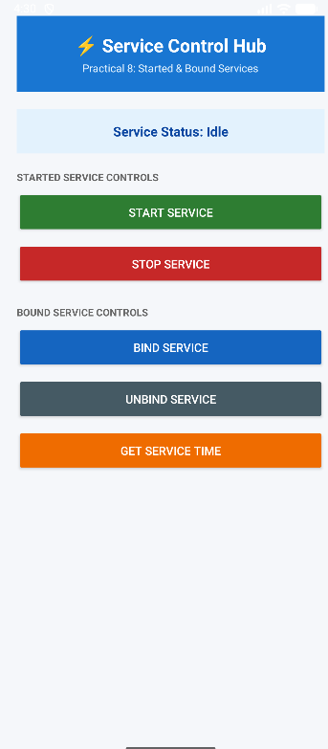

2.Develop an Android application implementing Notifications using Notification Manager.

activity_main.xml
<?xml version="1.0" encoding="utf-8"?>
<LinearLayout xmlns:android="http://schemas.android.com/apk/res/android"
android:layout_width="match_parent"
android:layout_height="match_parent"
android:orientation="vertical"
android:gravity="center"
android:padding="25dp">
<TextView
android:id="@+id/tvTitle"
android:layout_width="match_parent"
android:layout_height="wrap_content"
android:text="Notification Demo"
android:textSize="26sp"
android:textStyle="bold"
android:gravity="center"
android:padding="20dp" />
<Button
android:id="@+id/btnShowNotification"
android:layout_width="match_parent"
android:layout_height="wrap_content"
android:text="Show Notification" />
<Button
android:id="@+id/btnClearNotification"
android:layout_width="match_parent"
android:layout_height="wrap_content"
android:text="Clear Notification"
android:layout_marginTop="15dp" />
</LinearLayout>

MainActivity.kt
package com.example.practical23
import android.Manifest
import android.app.NotificationChannel
import android.app.NotificationManager
import android.content.pm.PackageManager
import android.os.Build
import android.os.Bundle
import android.widget.Button
import android.widget.Toast
import androidx.appcompat.app.AppCompatActivity
import androidx.core.app.ActivityCompat
import androidx.core.app.NotificationCompat
import androidx.core.app.NotificationManagerCompat

class MainActivity : AppCompatActivity() {
private val channelId = "notification_channel"
private val notificationId = 101
override fun onCreate(savedInstanceState: Bundle?) {
super.onCreate(savedInstanceState)
setContentView(R.layout.activity_main)
val btnShowNotification =
findViewById<Button>(R.id.btnShowNotification)
val btnClearNotification =
findViewById<Button>(R.id.btnClearNotification)
createNotificationChannel()
btnShowNotification.setOnClickListener {
showNotification()
}
btnClearNotification.setOnClickListener {
NotificationManagerCompat
.from(this)
.cancel(notificationId)
Toast.makeText(
this,
"Notification cleared",
Toast.LENGTH_SHORT
).show()
}
}
private fun createNotificationChannel() {
if (Build.VERSION.SDK_INT >= Build.VERSION_CODES.O) {
val channel = NotificationChannel(
channelId,
"My Notifications",
NotificationManager.IMPORTANCE_DEFAULT
)
channel.description =
"Channel for practical notifications"
val notificationManager =
getSystemService(
NotificationManager::class.java
)
notificationManager.createNotificationChannel(channel)
}
}
private fun showNotification() {
if (Build.VERSION.SDK_INT >= Build.VERSION_CODES.TIRAMISU) {
if (ActivityCompat.checkSelfPermission(
this,
Manifest.permission.POST_NOTIFICATIONS
) != PackageManager.PERMISSION_GRANTED
) {
ActivityCompat.requestPermissions(
this,
arrayOf(Manifest.permission.POST_NOTIFICATIONS),
100
)
return
}
}
val notification =
NotificationCompat.Builder(this, channelId)
.setSmallIcon(android.R.drawable.ic_dialog_info)
.setContentTitle("Android Notification")
.setContentText(
"This is a notification from my Android application."
)
.setPriority(NotificationCompat.PRIORITY_DEFAULT)
.setAutoCancel(true)
.build()
NotificationManagerCompat
.from(this)
.notify(notificationId, notification)
Toast.makeText(
this,
"Notification displayed",
Toast.LENGTH_SHORT
).show()
}
}

Add Notification Permission
Open: app → manifests → AndroidManifest.xml
Add this line above the <application> tag:
<uses-permission android:name="android.permission.POST_NOTIFICATIONS" />

Output:-
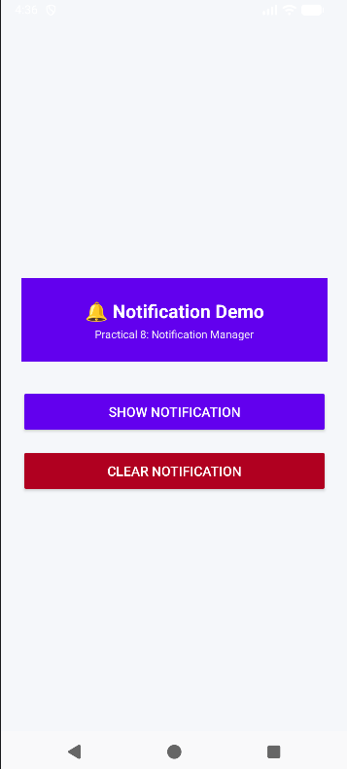

3. Develop an Android application implementing Static and Dynamic Broadcast Receivers.

activity_main.xml
<?xml version="1.0" encoding="utf-8"?>
<LinearLayout xmlns:android="http://schemas.android.com/apk/res/android"
android:layout_width="match_parent"
android:layout_height="match_parent"
android:orientation="vertical"
android:gravity="center"
android:background="#F5F7FA"
android:padding="24dp">

<!-- Header Card Banner -->
<LinearLayout
android:layout_width="match_parent"
android:layout_height="wrap_content"
android:orientation="vertical"
android:background="#0F9D58"
android:padding="24dp"
android:gravity="center"
android:layout_marginBottom="24dp">

<TextView
android:layout_width="wrap_content"
android:layout_height="wrap_content"
android:text="📡 Broadcast Hub"
android:textSize="22sp"
android:textStyle="bold"
android:textColor="#FFFFFF" />

<TextView
android:layout_width="wrap_content"
android:layout_height="wrap_content"
android:text="Practical 8: Static &amp; Dynamic Receivers"
android:textSize="13sp"
android:textColor="#E8F5E9"
android:layout_marginTop="4dp" />
</LinearLayout>

<Button
android:id="@+id/btnStatic"
android:layout_width="match_parent"
android:layout_height="52dp"
android:text="Send Static Broadcast"
android:textSize="16sp"
android:backgroundTint="#0F9D58"
android:textColor="#FFFFFF"
android:layout_marginBottom="12dp" />

<Button
android:id="@+id/btnDynamic"
android:layout_width="match_parent"
android:layout_height="52dp"
android:text="Send Dynamic Broadcast"
android:textSize="16sp"
android:backgroundTint="#1976D2"
android:textColor="#FFFFFF"
android:layout_marginBottom="24dp" />

<!-- Result Display Status -->
<TextView
android:id="@+id/tvResult"
android:layout_width="match_parent"
android:layout_height="wrap_content"
android:text="Broadcast result will appear here"
android:textSize="16sp"
android:textStyle="bold"
android:textColor="#333333"
android:background="#FFFFFF"
android:gravity="center"
android:padding="20dp" />

</LinearLayout>
Create StaticReceiver.kt
Go to your package: Right Click → New → Kotlin Class/File
Name: StaticReceiver

StaticReceiver.kt
package com.example.practical_8

import android.content.BroadcastReceiver
import android.content.Context
import android.content.Intent
import android.widget.Toast

class StaticReceiver : BroadcastReceiver() {
override fun onReceive(context: Context, intent: Intent) {
if (intent.action == "com.example.practical_8.STATIC_BROADCAST") {
Toast.makeText(
context,
"Static Broadcast Received Successfully!",
Toast.LENGTH_SHORT
).show()
}
}
}
Create DynamicReceiver.kt
Create another Kotlin class: Right Click → New → Kotlin Class/File
Name: DynamicReceiver

DynamicReceiver.kt
package com.example.practical_8

import android.content.BroadcastReceiver
import android.content.Context
import android.content.Intent
import android.widget.Toast

class DynamicReceiver : BroadcastReceiver() {
override fun onReceive(context: Context, intent: Intent) {
if (intent.action == "com.example.practical_8.DYNAMIC_BROADCAST") {
Toast.makeText(
context,
"Dynamic Broadcast Received Successfully!",
Toast.LENGTH_SHORT
).show()
}
}
}
MainActivity.kt
package com.example.practical_8

import android.content.Intent
import android.content.IntentFilter
import android.os.Bundle
import android.widget.Button
import android.widget.TextView
import androidx.appcompat.app.AppCompatActivity
import androidx.core.content.ContextCompat

class MainActivity : AppCompatActivity() {
private lateinit var tvResult: TextView
private lateinit var dynamicReceiver: DynamicReceiver

private val dynamicIntentFilter = IntentFilter(
"com.example.practical_8.DYNAMIC_BROADCAST"
)

override fun onCreate(savedInstanceState: Bundle?) {
super.onCreate(savedInstanceState)
setContentView(R.layout.activity_main)

val btnStatic = findViewById<Button>(R.id.btnStatic)
val btnDynamic = findViewById<Button>(R.id.btnDynamic)
tvResult = findViewById(R.id.tvResult)

// Register Dynamic Broadcast Receiver at runtime
dynamicReceiver = DynamicReceiver()
ContextCompat.registerReceiver(
this,
dynamicReceiver,
dynamicIntentFilter,
ContextCompat.RECEIVER_NOT_EXPORTED
)

btnStatic.setOnClickListener {
val intent = Intent("com.example.practical_8.STATIC_BROADCAST")
intent.setPackage(packageName)
sendBroadcast(intent)
tvResult.text = "Status: Static Broadcast Sent"
}

btnDynamic.setOnClickListener {
val intent = Intent("com.example.practical_8.DYNAMIC_BROADCAST")
sendBroadcast(intent)
tvResult.text = "Status: Dynamic Broadcast Sent"
}
}

override fun onDestroy() {
super.onDestroy()
// Unregister dynamic receiver to prevent memory leaks
unregisterReceiver(dynamicReceiver)
}
}
Add Static Receiver to AndroidManifest.xml
Open: app → manifests → AndroidManifest.xml
Inside the <application> tag, add:
<receiver
android:name=".StaticReceiver"
android:exported="false">
<intent-filter>
<action
android:name="com.example.practical9.STATIC_BROADCAST" />
</intent-filter>
</receiver>

Output:-
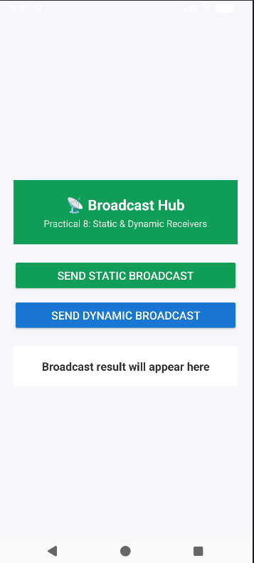

PRACTICAL 9

Database and Networking
1. Develop an Android application implementing SQLite database CRUD operations.
activity_main.xml
<?xml version="1.0" encoding="utf-8"?>
<LinearLayout xmlns:android="http://schemas.android.com/apk/res/android"
android:layout_width="match_parent"
android:layout_height="match_parent"
android:orientation="vertical"
android:padding="20dp">
<TextView
android:layout_width="match_parent"
android:layout_height="wrap_content"
android:text="Student SQLite Database"
android:textSize="25sp"
android:textStyle="bold"
android:gravity="center"
android:padding="15dp" />
<EditText
android:id="@+id/etId"
android:layout_width="match_parent"
android:layout_height="wrap_content"
android:hint="Enter Student ID"
android:inputType="number" />
<EditText
android:id="@+id/etName"
android:layout_width="match_parent"
android:layout_height="wrap_content"
android:hint="Enter Student Name"
android:inputType="textPersonName" />
<EditText
android:id="@+id/etCourse"
android:layout_width="match_parent"
android:layout_height="wrap_content"
android:hint="Enter Course"
android:inputType="text" />
<Button
android:id="@+id/btnInsert"
android:layout_width="match_parent"
android:layout_height="wrap_content"
android:text="Insert Student"
android:layout_marginTop="10dp" />
<Button
android:id="@+id/btnView"
android:layout_width="match_parent"
android:layout_height="wrap_content"
android:text="View Students" />
<Button
android:id="@+id/btnUpdate"
android:layout_width="match_parent"
android:layout_height="wrap_content"
android:text="Update Student" />
<Button
android:id="@+id/btnDelete"
android:layout_width="match_parent"
android:layout_height="wrap_content"
android:text="Delete Student" />
<TextView
android:id="@+id/tvResult"
android:layout_width="match_parent"
android:layout_height="wrap_content"
android:text="Database records will appear here"
android:textSize="17sp"
android:padding="15dp" />
</LinearLayout>
Create DatabaseHelper.kt
Go to your package: Right Click → New → Kotlin Class/File
Name: DatabaseHelper

DatabaseHelper.kt
package com.example.practical25
import android.content.ContentValues
import android.content.Context
import android.database.sqlite.SQLiteDatabase
import android.database.sqlite.SQLiteOpenHelper
class DatabaseHelper(context: Context) :
SQLiteOpenHelper(context, DATABASE_NAME, null, DATABASE_VERSION) {
companion object {
private const val DATABASE_NAME = "StudentDB"
private const val DATABASE_VERSION = 1
private const val TABLE_NAME = "students"
private const val COL_ID = "id"
private const val COL_NAME = "name"
private const val COL_COURSE = "course"
}
override fun onCreate(db: SQLiteDatabase) {
val createTable = """
CREATE TABLE $TABLE_NAME (
$COL_ID INTEGER PRIMARY KEY,
$COL_NAME TEXT,
$COL_COURSE TEXT
)
""".trimIndent()
db.execSQL(createTable)
}
override fun onUpgrade(
db: SQLiteDatabase,
oldVersion: Int,
newVersion: Int
) {
db.execSQL("DROP TABLE IF EXISTS $TABLE_NAME")
onCreate(db)
}
fun insertStudent(
id: Int,
name: String,
course: String
): Boolean {
val db = writableDatabase
val values = ContentValues()
values.put(COL_ID, id)
values.put(COL_NAME, name)
values.put(COL_COURSE, course)
val result = db.insert(
TABLE_NAME,
null,
values
)
return result != -1L
}
fun getAllStudents(): String {
val db = readableDatabase
val cursor = db.rawQuery(
"SELECT * FROM $TABLE_NAME",
null
)
val result = StringBuilder()
if (cursor.moveToFirst()) {
do {
val id =
cursor.getInt(
cursor.getColumnIndexOrThrow(COL_ID)
)
val name =
cursor.getString(
cursor.getColumnIndexOrThrow(COL_NAME)
)
val course =
cursor.getString(
cursor.getColumnIndexOrThrow(COL_COURSE)
)
result.append(
"ID: $id\nName: $name\nCourse: $course\n\n"
)
} while (cursor.moveToNext())
} else {
result.append("No records found")
}
cursor.close()
return result.toString()
}
fun updateStudent(
id: Int,
name: String,
course: String
): Boolean {
val db = writableDatabase
val values = ContentValues()
values.put(COL_NAME, name)
values.put(COL_COURSE, course)
val result = db.update(
TABLE_NAME,
values,
"$COL_ID = ?",
arrayOf(id.toString())
)
return result > 0
}
fun deleteStudent(id: Int): Boolean {
val db = writableDatabase
val result = db.delete(
TABLE_NAME,
"$COL_ID = ?",
arrayOf(id.toString())
)
return result > 0
}
}

MainActivity.kt
package com.example.practical25
import android.os.Bundle
import android.widget.Button
import android.widget.EditText
import android.widget.TextView
import android.widget.Toast
import androidx.appcompat.app.AppCompatActivity
class MainActivity : AppCompatActivity() {
private lateinit var databaseHelper: DatabaseHelper
override fun onCreate(savedInstanceState: Bundle?) {
super.onCreate(savedInstanceState)
setContentView(R.layout.activity_main)
databaseHelper = DatabaseHelper(this)
val etId = findViewById<EditText>(R.id.etId)
val etName = findViewById<EditText>(R.id.etName)
val etCourse = findViewById<EditText>(R.id.etCourse)
val btnInsert = findViewById<Button>(R.id.btnInsert)
val btnView = findViewById<Button>(R.id.btnView)
val btnUpdate = findViewById<Button>(R.id.btnUpdate)
val btnDelete = findViewById<Button>(R.id.btnDelete)
val tvResult = findViewById<TextView>(R.id.tvResult)
btnInsert.setOnClickListener {
val idText = etId.text.toString()
val name = etName.text.toString()
val course = etCourse.text.toString()
if (idText.isEmpty() ||
name.isEmpty() ||
course.isEmpty()
) {
Toast.makeText(
this,
"Please enter all details",
Toast.LENGTH_SHORT
).show()
return@setOnClickListener
}
val id = idText.toInt()
val success = databaseHelper.insertStudent(
id,
name,
course
)
if (success) {
Toast.makeText(
this,
"Student inserted successfully",
Toast.LENGTH_SHORT
).show()
etId.text.clear()
etName.text.clear()
etCourse.text.clear()
} else {
Toast.makeText(
this,
"Insertion failed. ID may already exist.",
Toast.LENGTH_SHORT
).show()
}
}
btnView.setOnClickListener {
val data = databaseHelper.getAllStudents()
tvResult.text = data
}
btnUpdate.setOnClickListener {
val idText = etId.text.toString()
val name = etName.text.toString()
val course = etCourse.text.toString()
if (idText.isEmpty() ||
name.isEmpty() ||
course.isEmpty()
) {
Toast.makeText(
this,
"Enter ID, Name and Course",
Toast.LENGTH_SHORT
).show()
return@setOnClickListener
}
val id = idText.toInt()
val success = databaseHelper.updateStudent(
id,
name,
course
)
if (success) {
Toast.makeText(
this,
"Student updated successfully",
Toast.LENGTH_SHORT
).show()
} else {
Toast.makeText(
this,
"Student not found",
Toast.LENGTH_SHORT
).show()
}
}
btnDelete.setOnClickListener {
val idText = etId.text.toString()
if (idText.isEmpty()) {
Toast.makeText(
this,
"Enter Student ID",
Toast.LENGTH_SHORT
).show()
return@setOnClickListener
}
val id = idText.toInt()
val success = databaseHelper.deleteStudent(id)
if (success) {
Toast.makeText(
this,
"Student deleted successfully",
Toast.LENGTH_SHORT
).show()
etId.text.clear()
} else {
Toast.makeText(
this,
"Student not found",
Toast.LENGTH_SHORT
).show()
}
}
}
}

Output:-
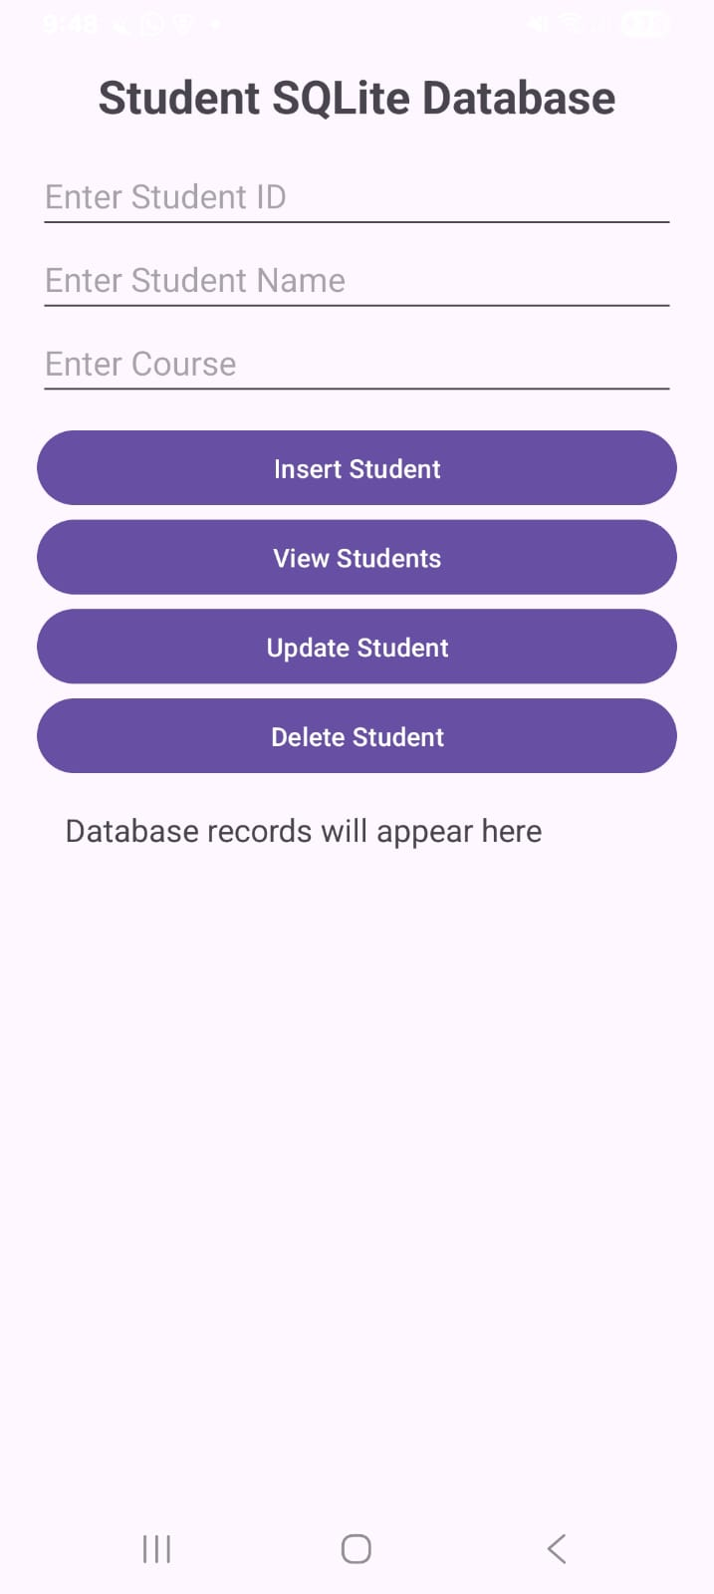
2. Develop an Android application integrating SQLite with ListView or RecyclerView.
Add RecyclerView Dependency
Open: Gradle Scripts → build.gradle.kts (Module :app)
Inside dependencies { }, add:
implementation("androidx.recyclerview:recyclerview:1.3.2")
Then click: Sync Now

activity_main.xml
<?xml version="1.0" encoding="utf-8"?>
<LinearLayout xmlns:android="http://schemas.android.com/apk/res/android"
android:layout_width="match_parent"
android:layout_height="match_parent"
android:orientation="vertical"
android:padding="15dp">
<TextView
android:layout_width="match_parent"
android:layout_height="wrap_content"
android:text="SQLite + RecyclerView"
android:textSize="25sp"
android:textStyle="bold"
android:gravity="center"
android:padding="15dp" />
<EditText
android:id="@+id/etId"
android:layout_width="match_parent"
android:layout_height="wrap_content"
android:hint="Student ID"
android:inputType="number" />
<EditText
android:id="@+id/etName"
android:layout_width="match_parent"
android:layout_height="wrap_content"
android:hint="Student Name"
android:inputType="textPersonName" />
<EditText
android:id="@+id/etCourse"
android:layout_width="match_parent"
android:layout_height="wrap_content"
android:hint="Course"
android:inputType="text" />
<Button
android:id="@+id/btnAdd"
android:layout_width="match_parent"
android:layout_height="wrap_content"
android:text="Add Student"
android:layout_marginTop="8dp" />
<androidx.recyclerview.widget.RecyclerView
android:id="@+id/recyclerView"
android:layout_width="match_parent"
android:layout_height="0dp"
android:layout_weight="1"
android:layout_marginTop="10dp" />
</LinearLayout>

Create Student.kt
Create a Kotlin class: Right Click package → New → Kotlin Class/File
Name: Student

Student.kt
package com.example.practical26
data class Student(
val id: Int,
val name: String,
val course: String
)

Create DatabaseHelper.kt
Same as Student.kt

DatabaseHelper.kt
package com.example.practical26
import android.content.ContentValues
import android.content.Context
import android.database.sqlite.SQLiteDatabase
import android.database.sqlite.SQLiteOpenHelper
class DatabaseHelper(context: Context) :
SQLiteOpenHelper(
context,
DATABASE_NAME,
null,
DATABASE_VERSION
) {
companion object
private const val DATABASE_NAME = "StudentDB"
private const val DATABASE_VERSION = 1
private const val TABLE_NAME = "students"
private const val COL_ID = "id"
private const val COL_NAME = "name"
private const val COL_COURSE = "course"
}
override fun onCreate(db: SQLiteDatabase) {
val query = """
CREATE TABLE $TABLE_NAME (
$COL_ID INTEGER PRIMARY KEY,
$COL_NAME TEXT,
$COL_COURSE TEXT
)
""".trimIndent()
db.execSQL(query)
}
override fun onUpgrade(
db: SQLiteDatabase,
oldVersion: Int,
newVersion: Int
) {
db.execSQL(
"DROP TABLE IF EXISTS $TABLE_NAME"
)
onCreate(db)
}
fun insertStudent(
id: Int,
name: String,
course: String
): Boolean {
val db = writableDatabase
val values = ContentValues()
values.put(COL_ID, id)
values.put(COL_NAME, name)
values.put(COL_COURSE, course)
val result = db.insert(
TABLE_NAME,
null,
values
)
return result != -1L
}
fun getAllStudents(): ArrayList<Student> {
val studentList = ArrayList<Student>()
val db = readableDatabase
val cursor = db.rawQuery(
"SELECT * FROM $TABLE_NAME",
null
)
if (cursor.moveToFirst()) {
do {
val id = cursor.getInt(
cursor.getColumnIndexOrThrow(COL_ID)
)
val name = cursor.getString(
cursor.getColumnIndexOrThrow(COL_NAME)
)
val course = cursor.getString(
cursor.getColumnIndexOrThrow(COL_COURSE)
)
studentList.add(
Student(id, name, course)
)
} while (cursor.moveToNext())
}
cursor.close()
return studentList
}
fun deleteStudent(id: Int): Boolean {
val db = writableDatabase
val result = db.delete(
TABLE_NAME,
"$COL_ID = ?",
arrayOf(id.toString())
)
return result > 0
}
}

Create StudentAdapter.kt
Same as Student.kt

StudentAdapter.kt
package com.example.practical26
import android.view.LayoutInflater
import android.view.View
import android.view.ViewGroup
import android.widget.TextView
import androidx.recyclerview.widget.RecyclerView
class StudentAdapter(
private val studentList: ArrayList<Student>,
private val onDeleteClick: (Student) -> Unit
) : RecyclerView.Adapter<StudentAdapter.StudentViewHolder>() {
class StudentViewHolder(itemView: View) :
RecyclerView.ViewHolder(itemView) {
val tvId: TextView =
itemView.findViewById(R.id.tvId)
val tvName: TextView =
itemView.findViewById(R.id.tvName)
val tvCourse: TextView =
itemView.findViewById(R.id.tvCourse)
val tvDelete: TextView =
itemView.findViewById(R.id.tvDelete)
}
override fun onCreateViewHolder(
parent: ViewGroup,
viewType: Int
): StudentViewHolder {
val view = LayoutInflater.from(parent.context)
.inflate(
R.layout.student_item,
parent,
false
)
return StudentViewHolder(view)
}
override fun onBindViewHolder(
holder: StudentViewHolder,
position: Int
) {
val student = studentList[position]
holder.tvId.text =
"ID: ${student.id}"
holder.tvName.text =
"Name: ${student.name}"
holder.tvCourse.text =
"Course: ${student.course}"

holder.tvDelete.setOnClickListener {

onDeleteClick(student)
}
}
override fun getItemCount(): Int {
return studentList.size
}
}

Create student_item.xml
Go to: res → layout → Right Click → New → Layout Resource File
Name: student_item

student_item.xml
<?xml version="1.0" encoding="utf-8"?>
<LinearLayout xmlns:android="http://schemas.android.com/apk/res/android"
android:layout_width="match_parent"
android:layout_height="wrap_content"
android:orientation="vertical"
android:padding="15dp"
android:layout_margin="5dp">
<TextView
android:id="@+id/tvId"
android:layout_width="match_parent"
android:layout_height="wrap_content"
android:text="ID: 1"
android:textSize="17sp"
android:textStyle="bold" />
<TextView
android:id="@+id/tvName"
android:layout_width="match_parent"
android:layout_height="wrap_content"
android:text="Name: Rahul"
android:textSize="17sp" />
<TextView
android:id="@+id/tvCourse"
android:layout_width="match_parent"
android:layout_height="wrap_content"
android:text="Course: B.Sc. IT"
android:textSize="17sp" />
<TextView
android:id="@+id/tvDelete"
android:layout_width="wrap_content"
android:layout_height="wrap_content"
android:text="DELETE"
android:textStyle="bold"
android:padding="8dp"
android:clickable="true"
android:focusable="true" />
</LinearLayout>

MainActivity.kt
package com.example.practical26
import android.os.Bundle
import android.widget.Button
import android.widget.EditText
import android.widget.Toast
import androidx.appcompat.app.AppCompatActivity
import androidx.recyclerview.widget.LinearLayoutManager
import androidx.recyclerview.widget.RecyclerView
class MainActivity : AppCompatActivity() {
private lateinit var databaseHelper: DatabaseHelper
private lateinit var adapter: StudentAdapter
private lateinit var etId: EditText
private lateinit var etName: EditText
private lateinit var etCourse: EditText
private val studentList = ArrayList<Student>()
override fun onCreate(savedInstanceState: Bundle?) {
super.onCreate(savedInstanceState)
setContentView(R.layout.activity_main)
databaseHelper = DatabaseHelper(this)
etId = findViewById(R.id.etId)
etName = findViewById(R.id.etName)
etCourse = findViewById(R.id.etCourse)
val btnAdd =
findViewById<Button>(R.id.btnAdd)
val recyclerView =
findViewById<RecyclerView>(R.id.recyclerView)
adapter = StudentAdapter(
studentList
) { student ->
deleteStudent(student)
}
recyclerView.layoutManager =
LinearLayoutManager(this)
recyclerView.adapter = adapter
loadStudents()
btnAdd.setOnClickListener {
addStudent()
}
}
private fun addStudent() {
val idText = etId.text.toString()
val name = etName.text.toString()
val course = etCourse.text.toString()
if (
idText.isEmpty() ||
name.isEmpty() ||
course.isEmpty()
) {
Toast.makeText(
this,
"Please enter all details",
Toast.LENGTH_SHORT
).show()
return
}
val id = idText.toInt()
val success =
databaseHelper.insertStudent(
id,
name,
course
)
if (success) {
Toast.makeText(
this,
"Student added successfully",
Toast.LENGTH_SHORT
).show()
etId.text.clear()
etName.text.clear()
etCourse.text.clear()
loadStudents()
} else {
Toast.makeText(
this,
"ID already exists",
Toast.LENGTH_SHORT
).show()
}
}
private fun loadStudents() {
studentList.clear()
studentList.addAll(
databaseHelper.getAllStudents()
)
adapter.notifyDataSetChanged()
}
private fun deleteStudent(student: Student) {
val success =
databaseHelper.deleteStudent(student.id)
if (success) {
Toast.makeText(
this,
"Student deleted",
Toast.LENGTH_SHORT
).show()
loadStudents()
}
}
}

Output:-
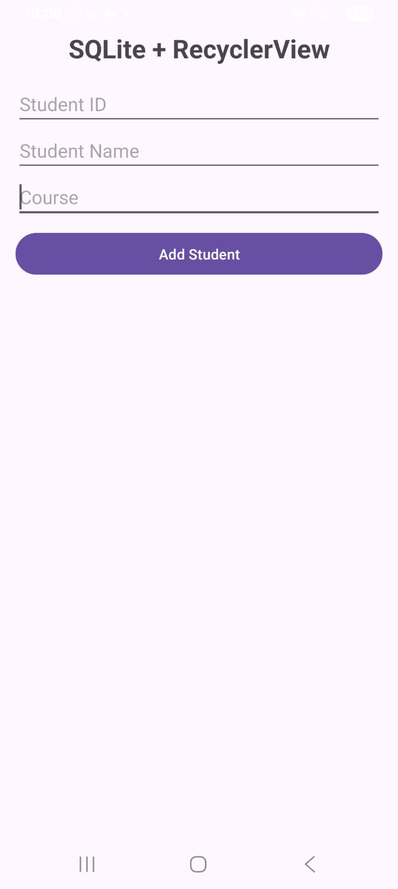
3. Develop an Android application to fetch and parse JSON data from a web service and display it in UI components.

Add Internet Permission
Open: app → manifests → AndroidManifest.xml
Add this line above <application>:
<uses-permission android:name="android.permission.INTERNET" />

Add Dependencies
Open: Gradle Scripts → build.gradle.kts (Module :app)
Inside dependencies { }, add:
implementation("com.squareup.okhttp3:okhttp:4.12.0")
implementation("org.jetbrains.kotlinx:kotlinx-coroutines-android:1.8.1")

activity_main.xml
<?xml version="1.0" encoding="utf-8"?>
<LinearLayout xmlns:android="http://schemas.android.com/apk/res/android"
android:layout_width="match_parent"
android:layout_height="match_parent"
android:orientation="vertical"
android:padding="20dp">
<TextView
android:layout_width="match_parent"
android:layout_height="wrap_content"
android:text="JSON Web Service Demo"
android:textSize="25sp"
android:textStyle="bold"
android:gravity="center"
android:padding="15dp" />
<Button
android:id="@+id/btnFetch"
android:layout_width="match_parent"
android:layout_height="wrap_content"
android:text="Fetch JSON Data" />
<ProgressBar
android:id="@+id/progressBar"
android:layout_width="wrap_content"
android:layout_height="wrap_content"
android:layout_gravity="center"
android:visibility="gone"
android:layout_margin="10dp" />
<ScrollView
android:layout_width="match_parent"
android:layout_height="0dp"
android:layout_weight="1">
<TextView
android:id="@+id/tvResult"
android:layout_width="match_parent"
android:layout_height="wrap_content"
android:text="JSON data will appear here"
android:textSize="17sp"
android:padding="10dp" />
</ScrollView>
</LinearLayout>

Create User.kt
Create a Kotlin class: Right Click package → New → Kotlin Class/File
Name: User

User.kt
package com.example.practical27
data class User(
val id: Int,
val name: String,
val email: String
)

MainActivity.kt
package com.example.practical27
import android.os.Bundle
import android.view.View
import android.widget.Button
import android.widget.ProgressBar
import android.widget.TextView
import android.widget.Toast
import androidx.appcompat.app.AppCompatActivity
import androidx.lifecycle.lifecycleScope
import kotlinx.coroutines.Dispatchers
import kotlinx.coroutines.launch
import kotlinx.coroutines.withContext
import okhttp3.OkHttpClient
import okhttp3.Request
import org.json.JSONArray
class MainActivity : AppCompatActivity() {
private lateinit var tvResult: TextView
private lateinit var progressBar: ProgressBar
private val client = OkHttpClient()
private val url =
"https://jsonplaceholder.typicode.com/users"
override fun onCreate(savedInstanceState: Bundle?) {
super.onCreate(savedInstanceState)
setContentView(R.layout.activity_main)
val btnFetch =
findViewById<Button>(R.id.btnFetch)
tvResult =
findViewById(R.id.tvResult)
progressBar =
findViewById(R.id.progressBar)
btnFetch.setOnClickListener {
fetchJsonData()
}
}
private fun fetchJsonData() {
progressBar.visibility = View.VISIBLE
tvResult.text = "Fetching data..."
lifecycleScope.launch {
try {
val jsonData = withContext(Dispatchers.IO) {
val request = Request.Builder()
.url(url)
.build()
client.newCall(request)
.execute()
.use { response ->
if (!response.isSuccessful) {
throw Exception(
"HTTP Error: ${response.code}"
)
}
response.body?.string()
?: throw Exception(
"Empty response"
)
}
}
val users = parseJson(jsonData)
val result = StringBuilder()
for (user in users) {
result.append(
"ID: ${user.id}\n"
)
result.append(
"Name: ${user.name}\n"
)
result.append(
"Email: ${user.email}\n\n"
)
}
tvResult.text = result.toString()
} catch (e: Exception) {
tvResult.text =
"Error: ${e.message}"
Toast.makeText(
this@MainActivity,
"Failed to fetch data",
Toast.LENGTH_SHORT
).show()
} finally {
progressBar.visibility = View.GONE
}
}
}
private fun parseJson(jsonData: String): ArrayList<User> {
val userList = ArrayList<User>()
val jsonArray = JSONArray(jsonData)
for (i in 0 until jsonArray.length()) {
val jsonObject =
jsonArray.getJSONObject(i)
val id =
jsonObject.getInt("id")
val name =
jsonObject.getString("name")
val email =
jsonObject.getString("email")
userList.add(
User(
id,
name,
email
)
)
}
return userList
}
}

Output:-
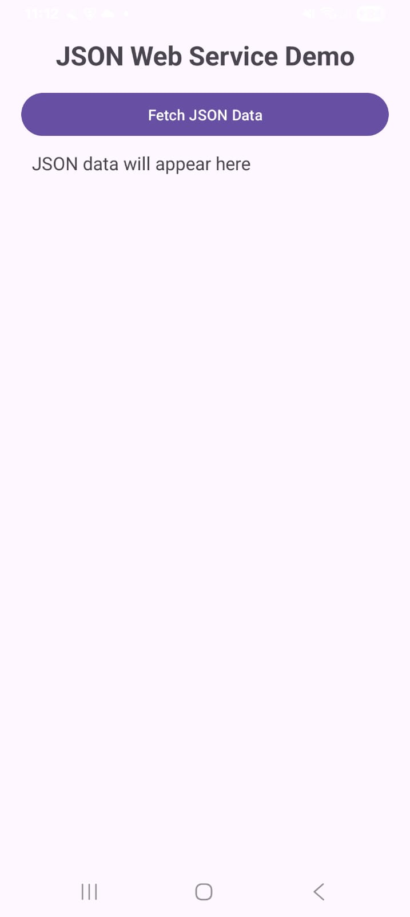

PRACTICAL 10

Concurrency, Media and Security
1. Develop an Android application demonstrating Threads and Handlers for background processing.
activity_main.xml
<?xml version="1.0" encoding="utf-8"?>
<LinearLayout xmlns:android="http://schemas.android.com/apk/res/android"
android:layout_width="match_parent"
android:layout_height="match_parent"
android:orientation="vertical"
android:gravity="center"
android:padding="25dp">
<TextView
android:id="@+id/tvTitle"
android:layout_width="match_parent"
android:layout_height="wrap_content"
android:text="Threads and Handlers"
android:textSize="26sp"
android:textStyle="bold"
android:gravity="center"
android:padding="20dp" />
<ProgressBar
android:id="@+id/progressBar"
style="?android:attr/progressBarStyleHorizontal"
android:layout_width="match_parent"
android:layout_height="wrap_content"
android:max="100"
android:progress="0" />
<TextView
android:id="@+id/tvProgress"
android:layout_width="match_parent"
android:layout_height="wrap_content"
android:text="Progress: 0%"
android:textSize="18sp"
android:gravity="center"
android:padding="15dp" />
<Button
android:id="@+id/btnStart"
android:layout_width="match_parent"
android:layout_height="wrap_content"
android:text="Start Background Task" />
</LinearLayout>

MainActivity.kt
package com.example.practical28
import android.os.Bundle
import android.os.Handler
import android.os.Looper
import android.widget.Button
import android.widget.ProgressBar
import android.widget.TextView
import androidx.appcompat.app.AppCompatActivity
class MainActivity : AppCompatActivity() {
private lateinit var progressBar: ProgressBar
private lateinit var tvProgress: TextView
private lateinit var btnStart: Button
private val handler = Handler(Looper.getMainLooper())
override fun onCreate(savedInstanceState: Bundle?) {
super.onCreate(savedInstanceState)
setContentView(R.layout.activity_main)
progressBar =
findViewById(R.id.progressBar)
tvProgress =
findViewById(R.id.tvProgress)
btnStart =
findViewById(R.id.btnStart)
btnStart.setOnClickListener {
startBackgroundTask()
}
}
private fun startBackgroundTask() {
btnStart.isEnabled = false
progressBar.progress = 0
tvProgress.text = "Progress: 0%"
Thread {
for (i in 1..100) {
Thread.sleep(50)
handler.post {
progressBar.progress = i
tvProgress.text =
"Progress: $i%"
}
}
handler.post {
tvProgress.text =
"Background Task Completed"
btnStart.isEnabled = true
}
}.start()
}
}

Output:-
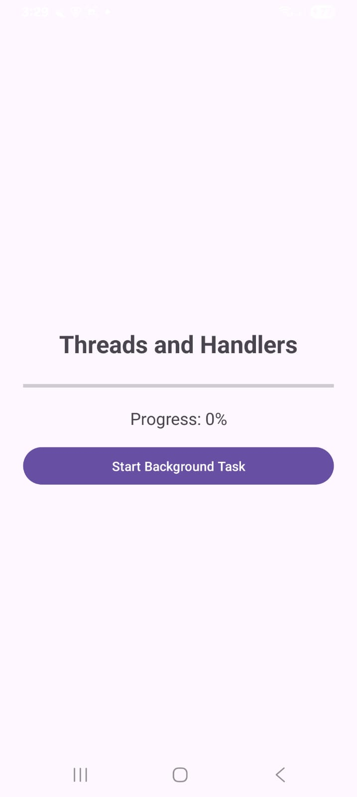

2. Develop an Android application implementing Media APIs and Telephone APIs.
Add an Audio File
First create the raw resource folder.
Go to: app → res → Right Click → New → Android Resource Directory
Set Resource type: raw
Click OK.
Then Download any Audio file(.mp3)
Name it "sample_audio"
Then put an audio file in raw directory

activity_main.xml
<?xml version="1.0" encoding="utf-8"?>
<LinearLayout xmlns:android="http://schemas.android.com/apk/res/android"
android:layout_width="match_parent"
android:layout_height="match_parent"
android:orientation="vertical"
android:gravity="center"
android:padding="25dp">
<TextView
android:id="@+id/tvTitle"
android:layout_width="match_parent"
android:layout_height="wrap_content"
android:text="Media and Telephone API"
android:textSize="25sp"
android:textStyle="bold"
android:gravity="center"
android:padding="20dp" />
<TextView
android:id="@+id/tvMediaStatus"
android:layout_width="match_parent"
android:layout_height="wrap_content"
android:text="Audio Player"
android:textSize="20sp"
android:gravity="center"
android:padding="15dp" />
<Button
android:id="@+id/btnPlay"
android:layout_width="match_parent"
android:layout_height="wrap_content"
android:text="Play Audio" />
<Button
android:id="@+id/btnPause"
android:layout_width="match_parent"
android:layout_height="wrap_content"
android:text="Pause Audio"
android:layout_marginTop="10dp" />
<Button
android:id="@+id/btnStop"
android:layout_width="match_parent"
android:layout_height="wrap_content"
android:text="Stop Audio"
android:layout_marginTop="10dp" />
<View
android:layout_width="match_parent"
android:layout_height="1dp"
android:layout_margin="20dp" />
<TextView
android:layout_width="match_parent"
android:layout_height="wrap_content"
android:text="Telephone API"
android:textSize="20sp"
android:textStyle="bold"
android:gravity="center"
android:padding="10dp" />
<Button
android:id="@+id/btnDial"
android:layout_width="match_parent"
android:layout_height="wrap_content"
android:text="Open Phone Dialer" />
</LinearLayout>

MainActivity.kt
package com.example.practical29
import android.content.Intent
import android.media.MediaPlayer
import android.net.Uri
import android.os.Bundle
import android.widget.Button
import android.widget.TextView
import android.widget.Toast
import androidx.appcompat.app.AppCompatActivity
class MainActivity : AppCompatActivity() {
private lateinit var mediaPlayer: MediaPlayer
override fun onCreate(savedInstanceState: Bundle?) {
super.onCreate(savedInstanceState)
setContentView(R.layout.activity_main)
val btnPlay =
findViewById<Button>(R.id.btnPlay)
val btnPause =
findViewById<Button>(R.id.btnPause)
val btnStop =
findViewById<Button>(R.id.btnStop)
val btnDial =
findViewById<Button>(R.id.btnDial)
val tvMediaStatus =
findViewById<TextView>(R.id.tvMediaStatus)
mediaPlayer = MediaPlayer.create(
this,
R.raw.sample_audio
)
btnPlay.setOnClickListener {
if (!mediaPlayer.isPlaying) {
mediaPlayer.start()
tvMediaStatus.text =
"Audio Playing"
}
}
btnPause.setOnClickListener {
if (mediaPlayer.isPlaying) {
mediaPlayer.pause()
tvMediaStatus.text =
"Audio Paused"
}
}
btnStop.setOnClickListener {
mediaPlayer.stop()
mediaPlayer.release()
mediaPlayer = MediaPlayer.create(
this,
R.raw.sample_audio
)
tvMediaStatus.text =
"Audio Stopped"
}
btnDial.setOnClickListener {
val phoneNumber = "9876543210"
val intent = Intent(
Intent.ACTION_DIAL,
Uri.parse("tel:$phoneNumber")
)
try {
startActivity(intent)
} catch (e: Exception) {
Toast.makeText(
this,
"Phone dialer not available",
Toast.LENGTH_SHORT
).show()
}
}
}
override fun onDestroy() {
if (::mediaPlayer.isInitialized) {
mediaPlayer.release()
}
super.onDestroy()
}
}

Output:-
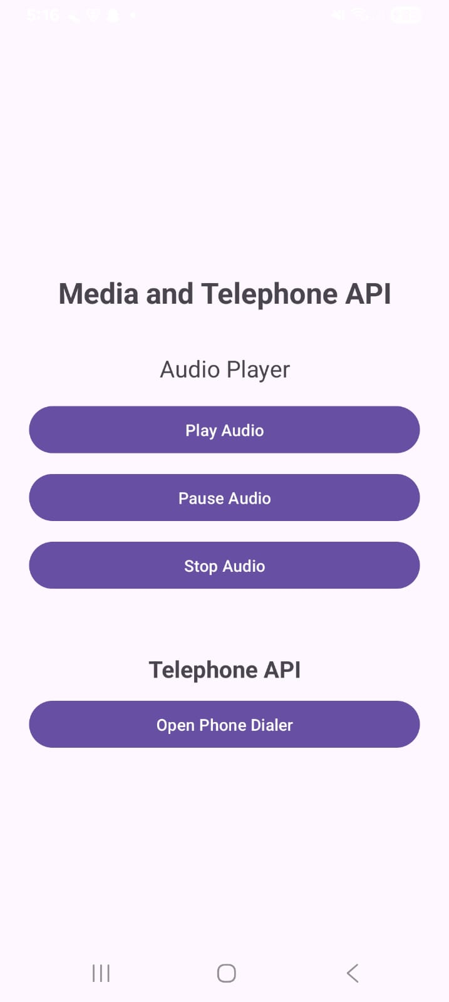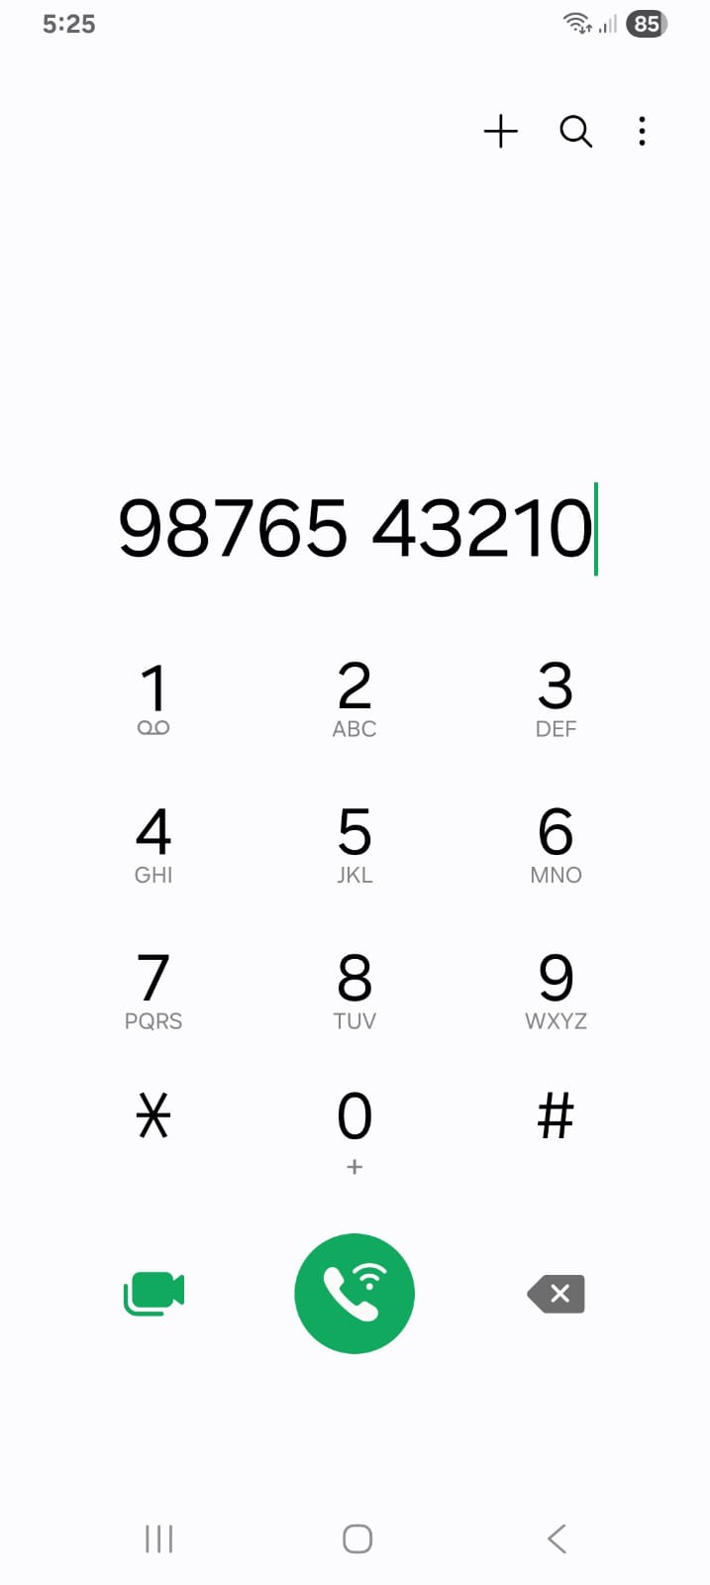

3. Develop an Android application implementing Runtime Permissions and security handling in AndroidManifest.xml.
activity_main.xml
<?xml version="1.0" encoding="utf-8"?>
<LinearLayout xmlns:android="http://schemas.android.com/apk/res/android"
android:layout_width="match_parent"
android:layout_height="match_parent"
android:orientation="vertical"
android:gravity="center"
android:padding="25dp">
<TextView
android:id="@+id/tvTitle"
android:layout_width="match_parent"
android:layout_height="wrap_content"
android:text="Runtime Permission Demo"
android:textSize="25sp"
android:textStyle="bold"
android:gravity="center"
android:padding="20dp" />
<TextView
android:id="@+id/tvStatus"
android:layout_width="match_parent"
android:layout_height="wrap_content"
android:text="Camera permission status: Not checked"
android:textSize="18sp"
android:gravity="center"
android:padding="15dp" />
<Button
android:id="@+id/btnPermission"
android:layout_width="match_parent"
android:layout_height="wrap_content"
android:text="Request Camera Permission" />
</LinearLayout>

AndroidManifest.xml
Open: app → manifests → AndroidManifest.xml
Add the camera permission above the <application> tag:
<uses-permission android:name="android.permission.CAMERA" />

MainActivity.kt
package com.example.practical30
import android.Manifest
import android.content.pm.PackageManager
import android.os.Bundle
import android.widget.Button
import android.widget.TextView
import android.widget.Toast
import androidx.activity.result.contract.ActivityResultContracts
import androidx.appcompat.app.AppCompatActivity
import androidx.core.content.ContextCompat
class MainActivity : AppCompatActivity() {
private lateinit var tvStatus: TextView
private val cameraPermissionLauncher =
registerForActivityResult(
ActivityResultContracts.RequestPermission()
) { isGranted ->
if (isGranted) {
tvStatus.text =
"Camera permission: Granted"
Toast.makeText(
this,
"Camera permission granted",
Toast.LENGTH_SHORT
).show()
} else {
tvStatus.text =
"Camera permission: Denied"
Toast.makeText(
this,
"Camera permission denied",
Toast.LENGTH_SHORT
).show()
}
}
override fun onCreate(savedInstanceState: Bundle?) {
super.onCreate(savedInstanceState)
setContentView(R.layout.activity_main)
tvStatus =
findViewById(R.id.tvStatus)
val btnPermission =
findViewById<Button>(R.id.btnPermission)
btnPermission.setOnClickListener {
checkCameraPermission()
}
}
private fun checkCameraPermission() {
when {
ContextCompat.checkSelfPermission(
this,
Manifest.permission.CAMERA
) == PackageManager.PERMISSION_GRANTED -> {
tvStatus.text =
"Camera permission: Already Granted"
Toast.makeText(
this,
"Permission already granted",
Toast.LENGTH_SHORT
).show()
}
else -> {
cameraPermissionLauncher.launch(
Manifest.permission.CAMERA
)
}
}
}
}

Output:-
